CHAPTER 1 INTRODUCTION TO THE STUDY

Background and Theoretical Framework of the Study

A disaster is an unfortunate event suddenly occurring uncontrollably and causes great damage or loss of life which exceeds the ability of the affected community or society to cope using its own resources (IFRC, 2022). Disaster poses danger to the community. Natural disasters seriously threaten human life and property. Every year, hundreds of thousands of lives are disrupted by disasters. There are long-term effects of every disaster on both people and property.

According to Ritchie and Roser (2014), natural disasters kill an average of 45,000 people per year globally and are responsible for 0.1% of deaths over the past decade ranging from 0.01% to 0.4%. In addition, the Emergency Event Database (EM-DAT) listed 432 global natural hazard-related catastrophes in 2021. In total, this led to 10,492 fatalities, impacted 101.8 million people, and resulted in economic losses of almost 252.1 billion US dollars. As a continent, Asia suffered 40% of all disaster events, 49% of all fatalities, and 66% of all affected individuals making it the most severely affected.

A 15-year global agreement to lessen, avoid, and respond to disaster hazards around the world is known as the Sendai Framework for Disaster Risk Reduction 2015–2030. It strives to increase societal and economic preparedness for disasters brought on by natural, biological, and technological risks, which are made worse by catastrophic weather patterns and slow-onset occurrences. The Sendai Framework, which was adopted by UN Member States at the Third UN World Conference in March 2015, emphasizes that local governments, the private sector, and other stakeholders should share responsibility for minimizing catastrophe risk with states as it is their primary job. The Sendai Framework specifically addresses the effect of catastrophes on relocation and emphasizes the value of utilizing migrants' expertise, skills, and capacities in the planning and execution of disaster risk reduction.

Disaster management plays a crucial role in preventing suffering. Disaster preparedness and management systems are used to protect the community’s safety during a disaster, as well as to assess and evaluate immediate response and recovery needs. Disaster management is a collective word that refers to all actions taken to prepare for the possibility of a catastrophic occurrence, such as mitigation, readiness, response, and long-term risk reduction strategies like reconstruction. Disaster readiness calls for contingency planning, advance decisions about managing human and monetary resources, coordinating procedures between different agencies, and organizing logistics (Tulane University, 2022). Disaster mitigation and prevention measures aim to limit the potential for disaster-related damage and suffering.

During disaster situations, the Local Government Unit must be able to assess the vulnerabilities of the area and must instill basic knowledge of natural disaster and the possible impacts (Dominggo & Monejar, 2018). According to DSWD Secretary Taguiwalo, the Local Government Code of 1991 also stipulates that local government units (LGUs) are responsible for conducting rescue operations, providing immediate relief assistance, setting up and managing evacuation centers, and ensuring that the community knows how to respond in a disaster. The role of local government under Disaster Management Act 2003 is to ensure local disaster information is promptly given to the District Disaster Coordinator, approve a local disaster management plan, and have a disaster response capability. The role of the community in disaster management can be determined by examining its involvement in all phases of the latter and how it reacts with other governance actors that help it deal with disasters. Every individual in a community seeks ways to effectively use local resources and capacities to better prepare for disasters, and to adopt measures to reduce their vulnerability.

The community is obligated to safeguard its members from the ravages of both natural and man-made disasters. Based on the R.A. 10121, barangay officials are the primary responders during calamities or disasters since they are the authorities closest to ground zero (Lomotan, 2014). Authorities assigned for disaster planning should examine and manage causal factors requiring extent assessment to which a community can withstand a disaster. For seeing what will happen after the disaster, the response, and what should be done ahead of time as part of contingency planning.

During a disaster event, there are gaps and barriers at the local level in mapping households prone to floods and landslides which puts even more danger to those who are at risk. After a disaster event, evaluation and proper assessment must be conducted for recovery planning to assist the community in rebuilding. However, in community situations, it takes time to collect the data of the affected households, and there is a lack of tools and resources in gathering the data for distribution of urgent needs. Moreover, generating organized data of each household plays an essential role for distribution and validity of rapid needs and damage assessment. Loss of power source and unstable signal is expected after a disaster. Due to this, there are delays in collecting and generating analysis of data of damaged infrastructure, affected households, and data regarding missing, injured, and dead individuals.

Objectives of the Study

In general, this study aimed to develop a community disaster management system with rapid assessment and damage reporting.

Specifically, it aimed to;

1. develop a module for generating data on households, especially vulnerable populations such as children, elderly, and persons with disabilities by integrating with offline data collection tools and mapping of households using an OpenStreetMap;
2. integrate an instrument for conducting rapid needs assessment for prioritizing the urgent needs of vulnerable populations;
3. integrate an instrument for conducting damage assessment for analysis and reporting;
4. develop a distribution route to calculate the shortest path to distribute the urgent needs of the vulnerable population; and
5. evaluate the system based on ISO 25010 software quality standard.

Significance of the Study

Developing a community disaster management system is necessary as this system assesses effects and impacts to the people and then determines their priority recovery needs in a barangay.

The generalization of this study would be a great contribution to the vast population in relation to preparedness and readiness of a certain area. Vital results of this investigation could be highly significant and beneficial especially to the following sectors:

Local Government Units. The researchers believe that this system will help LGUs to monitor everyone in the community before and after the disaster. This system will allow them to gain easy access to the data of the households, monitor casualties and affected individuals, and to prepare for recovery needs.

Community. This system will effectively ensure the preparedness of the community, use local resources and capacities to better prepare for disaster and to adopt measures to reduce their vulnerability. To assess their plans and ability to respond and recover from disaster.

Future Researchers*.* The researchers believe that this study will broaden the idea of the future researchers and will serve as a good source of accurate and useful information that will help them in conducting their own research studies, exploring more about community disaster preparedness in further explanation, understanding and also contributing to improving the research gaps regarding this area of research.

Definition of Terms

For better understanding of terms and concepts used in this study, the following terms and concepts were defined conceptually and operationally:

*Application Programming Interfaces* (*API)* —- It allows different applications to talk to each other and exchange information or functionality. This allows businesses to access another business’s data, piece of code, software, or services in order to extend the functionality of their own products — all while saving time and money (Fitzgerald, 2021).

In this study, the Application Programming Interfaces (API) is used to integrate tools and allows different software to connect with the proposed system.

*Damage Assessment* —- The process for determining the nature and extent of the loss, suffering, and/or harm to the community resulting from a natural, accidental or human-caused disaster (Emergency Management Agency, 2022).

In this study, the Damage Assessment is used to assess the total damages in the barangay.

*Disaster* –- A sudden event, such as an accident or a natural catastrophe, that causes great damage or loss of life (Oxford Languages and Google, 2022)

In this study, the Disaster refers to an event that the study is focusing on.

*KoboToolbox* —- It is a free open-source tool for mobile data collection, available to all. It allows the user to collect data in the field using mobile devices such as mobile phones or tablets, as well as with paper or computers (Ocha, 2022).

In this study, the KoboToolbox refers to the tool that will be integrated in the system that will be used in collecting the data from the households.

*Openstreetmap* —- It provides map data for thousands of websites, mobile apps, and hardware devices (OSM Contributors, 2003).

In this study, OpenStreetMap will be integrated in the system for household mapping and determining the high risk and low risk areas in the community.

*Rapid Needs Assessment* —- Performing a scoping exercise and a desk review about key health behaviors, knowledge, beliefs and norms should be carried out as part of emergency preparedness. In this way, communication experts have quick access to important data that can guide a rapid communication response (Emergency Management Agency, 2022).

In this study, the Rapid Needs Assessment is used to assess the affected households who need immediate help and support after the disaster.

Delimitation of the Study

The main focus of the study is to create a web-based system for community with rapid assessment and damage reporting that concentrates on data collection, analysis, management and use of relevant information and ensures its dissemination to the community, taking into account the needs of different categories of users, as appropriate before and after a disaster. The disasters such as flood, typhoon, earthquake, strong wind or heavy rainfall are the scope of the system. It develops, periodically adds and updates household information through integrating KoboToolbox API as a data collection tool. The basis of the assessment is based on the Rapid and Damage Needs Assessment (RDNA) Forms provided by the Municipal Disaster Risk Reduction and Management Office (MDRRMO).

The researchers used the leaflet routing machine to calculate the shortest route for the prioritization of the vulnerable population to provide their urgent needs, mapping of households that are identified as partially or totally damaged, and markings of households in the community. The system cannot send or receive messages from the population. There are some features that are not available offline.

The study only focuses on the community based Barangay Disaster Risk Reduction Council plan that they follow and only will only be implemented in the system. The system will be deployed in the barangay hall, not in the LGU, and to be managed by barangay officials.

CHAPTER 2 REVIEW OF RELATED SYSTEMS

Review of Existing and Related Systems

*Current System*

The Municipal Disaster Risk Reduction Management Office (MDRRMO) has an existing system that monitors the location of the household in each barangay. It is a GIS-based system that has only the mapping of the household. However, it does not have assessment of the affected persons and infrastructures. The Rapid and Disaster Needs Assessment (RDNA) forms were used in gathering the data of the affected persons and infrastructure. The data in the RDNA forms were manually written to gather data in every barangay. After collecting the data in every barangay, barangay officials manually summarize the data for the reporting of the municipal level status that will be submitted in the Provincial level. They have to tap the population office to have a copy of the household information in each barangay through Microsoft Excel if there has been an update in household information. Moreover, from the community’s perspective, the methods or way of monitoring the data of population is done in a traditional way by printing the reports each year.

*Related Systems*

*“GIS-Based Network Analysis for the Roads Network of the Greater Cairo Area”* by Ahmid et al. (2017) provides a thorough network analysis that makes use of Geographic Information System (GIS) capabilities to pinpoint the best path away from an incident's location for any healthcare service providers in the Greater Cairo Metropolitan Area. This related system shows that the best route travel time is much better than the shortest route travel time.

Similarly, both systems use Leaflet Routing Machine to calculate the shortest path in order to reach the location of vulnerable populations as fast as possible to provide needs and response. However, the proposed system uses leaflet routing machine for the incidents location to the healthcare services, while it aims to calculate the shortest route of the affected households for the distribution of the urgent needs.

*“A Geographic Information System for Disaster Relief Distribution on Natural Disaster Response”* by Meilani et al. (2021) was designed to provide information on optimal disaster relief distribution routes. This design is based on issues that arise during the distribution of disaster relief, such as the obstruction of the process due to abnormal road conditions and the lack of knowledge regarding the data of disaster relief needs at the evacuation posts, resulting in a mismatch between the disaster relief provided and the disaster relief needed on the evacuation post. The disaster relief distribution network is determined based on the Dijkstra algorithm. Similarly, both systems aim to calculate the shortest path for the immediate response to the vulnerable population. In contrast, the existing system uses the Dijkstra algorithm, while the proposed system uses the Leaflet routing machine to calculate the path for the distribution of needs.

*“A Mobile Disaster Management System Using Android Technology”* is a study developed by Fajardo and Oppus (2010). It is known as MyDisasterDroid that guides the volunteers and rescuers to determine the optimum routes along various geographic regions. It can provide assistance in the area with the shortest possible time and more people will be provided by the service. Both studies aim to find a route for the faster distribution of goods to the vulnerable population. In contrast, this study uses genetic algorithms for optimization and different parameters to determine the most optimum route, while the proposed system uses leaflet routing machines to calculate the route for the distribution of goods to the vulnerable population.

*“An Autonomous Wireless Sensor Network Deployment System Using Mobile Robots for Human Existence Detection in Case of Disasters”* is a study by Tuna et al. (2012). It can help the authorities and security forces measure radiation levels in affected areas without compromising the life of the rescue personnel. For this purpose, battery powered sensor nodes can be used to measure radiation levels automatically and send the latest data on radiation levels in real time using wireless technologies to multiple robots to perform a desired action. Similarly, both systems aim to assist and help people to respond, recover and lessen the casualties during disaster situations. In contrast, this study includes robots to assess the victim of a certain natural disaster including fully autonomous deployment, flexibility, and aggregated intelligence, while the proposed system does not use robots to response in the urgent needs of the vulnerable population.

*"Management System Using Free and Open-Source Technologies”* by Y. He et al. (2017) is a mobile-based post-disaster management system (MDMS) mainly used for collecting, sharing and disseminating disaster-induced damages/risks that was successfully developed under a combination of native and web application technologies. It is similar to the proposed system where the researchers will use a management system to gather information for disaster. The difference is that the management system has three phases: Data gathering, rapid needs assessment and damage assessment and reporting through KoboToolbox. The study will require further improvements to provide better user experiences and maximize its functionality.

*“Mobile App-Based Early Warning System for Landslides Using Land Monitoring Through GSM”* by Sejera et. al (2020). In this study, a landslide early warning system is being developed. It transmits messages as mobile SMS alerts using GSM modules outfitted with mobile applications with the indicators "Normal," "Warning," and "Danger." The sensors utilized by this early warning system are capable of detecting environmental factors that are known to cause landslides. A microprocessor, the Arduino Nano, then analyzes the data the sensors have collected. Similar to this study, it uses SMS to send warning messages to the vulnerable population who are at risk in the flood thru SMS. In spite of that, this system uses SMS Gateway API to send messages to the vulnerable population.

*"“HELP ME”: An Emergency Response Mobile Application"* by Caliston and Tabia (2021) provides a quick response to accidents by tracking the users' location during an emergency. The app features a red button to report emergencies, and notifications to automatically alarm the rescuer's phone. It also has features like a push notification alarm using Firebase, a video call using agora. io, and tracking the location of the accident through a leaflet map provider. Similarly, the proposed system uses the Openstreetmap to track the location of the vulnerable population and can filter by the system. In contrast, the proposed system uses a leaflet routing machine for the immediate response to the vulnerable population.

*"F-Zone: A Web-Based Dynamic Flood Map Information System"* by Samonte et al. (2022) is a web-based system that utilizes data from sensors and drones used to map, measure, and ascertain the extent of damage to the flooded area. Testing made to the system shows that every function has passed its test case and is working accordingly. Similarly, the proposed system has a damages assessment to measure the damages done by the disaster. In contrast, the proposed system uses KoboToolbox to assess the damage brought by the disaster.

*"The Community-Based Monitoring System (CBMS) as a Local Planning Tool: Results from the PIDS-DILG Baseline Study on Policy and Governance Gaps for the Local Government Support Fund Assistance to Municipalities (LGSF-AM) Program"* by Diokno-Sicat et al. (2020) provides data collection which generated information on current municipal local planning practices of the Municipal Planning Team (MPT) in the development and/or updating of the Comprehensive Development Plan (CDP). The CBMS was one of the data collection tools claimed to be utilized by the LGUs. For this report, responses of the LGUs on sections relating to CBMS were highlighted. Similarly, the proposed system provides the data collection of the household, rapid needs, and Damage assessment. In contrast, the proposed system uses KoboToolbox to collect data from the households of the barangay.

*"Disaster management 2.0: A Real-time Disaster Damage Assessment Model Based on Mobile Social Media Data—A case Study of Weibo (Chinese Twitter)"* a study of S. Shan et al. (2019) develops a framework for real-time urban disaster damage monitoring and assessment. Social media texts sent during and after the Tianjin explosion and Typhoon Nepartak disasters are collected and constitute the database. The real-time monitoring of physical damage and sentiment provides the main categories of damage and damage scale information. Similarly, the proposed system conducts a damage assessment for the post disaster. In contrast, the proposed system uses KoboToolbox to assess the damage infrastructures on a disaster.

*"Fairness in Ambulance Routing for Post Disaster Management"* is a study of R. Aringhieri et al. (2022) that aims to find the best ambulance tours to transport the patients during a disaster in relief operations while considering fairness and equity to deliver services to patients in balance. Similarly, the proposed system uses a routing machine for immediate response for the vulnerable population. In contrast, the proposed system uses the Leaflet Routing Machine to calculate the shortest path of a vulnerable population for immediate response in a disaster.

*"Research on Rapid Assessment Technology of Earthquake Disaster Loss Based on GIS"* by Q. Tan et al. (2019) develop a GIS-based rapid assessment system for earthquake disasters that has been deployed and applied in actual earthquake emergency work, providing a guarantee for improving earthquake emergency response capability and reducing earthquake disaster losses. Similarly, the proposed system assesses a rapid needs assessment for a disaster. In contrast, the proposed system uses KoboToolbox for rapid needs to assess the affected population.

CHAPTER 3 RESEARCH DESIGN AND METHODOLOGY

Description of the Proposed Study

This study aimed to develop a community disaster management system with rapid assessment and damage assessment. The web-based system can be utilized by the admin who are the assigned barangay officials. The system can identify which household has a child, senior and PWD through mapping in the map. Through the integration of the API, the KoboToolbox can be utilized as an offline collection tool for the collection of households, rapid needs assessment and damage reporting information by the data collector. Rapid needs assessments aimed to collect the data of the injured, missing and dead household members to assess impact of the disaster. Damage assessment can assess and monitor the damage infrastructure and the affected household for immediate assistance. The proposed system calculates routes with an integration of leaflet routing machines to provide the volunteers the shortest path to the affected household for providing urgent needs. The data that have been collected and analyzed by the system can be generated into summarized document reports and be submitted to the municipal level. Through the assessments that can be generated by the system to summarized reports, it identifies the magnitude of a disaster by focusing on the general impact on the society and the people's coping capacity.

*Assumptions and Preconditions*

The system will be deployed in the barangay hall and can be monitored by the assigned barangay official. Beforehand, the data collectors will create an account in the KoboToolbox to have authorization in collecting the data. The user can download the mobile application of KoboCollect and will serve as a data collection tool. The data of the household should be stored in the system before the process of assessment begins for the mapping of the system. There will be a filtering in every map to identify which household has a PWD, children and senior for prioritization. Using the leaflet routing machine, the system can calculate the shortest route for the distribution of the urgent needs of the population.

Methods and Proposed Enhancements

*Source of Information*

Forms. The researchers used the RDNA (Rapid and Damage Needs Assessment) form provided by the MDRRMO and had revised based on the set up they had decided for the assessments. Using these forms, the data collectors can collect the information of the affected households and can be assessed by the system for generating summarized reports.

Related Literature. The researchers reviewed past and recent related studies to gather enough information in conducting the proposed study. Documents such as journals, published papers, and articles were referenced and served as a bases to the researchers in the whole duration of study.

Interviews. It was conducted for the validation of the information to gather and compile the information in the initial stage of the study.

Repositories. The researchers took advantage of the open-sourced codes from the online repositories such as GitHub, W3Schools,and stackoverflow for the reference in development of the system.

Evaluation. The researchers used the evaluation form to assess the data that have been collected to describe performance efficiency as well as to determine the quality and compatibility of the system based on ISO 25010.

*Proposed Enhancements*

The enhancement that was utilized in this study was the shortest routes using a leaflet routing machine for the distribution of the urgent needs of the vulnerable population. This enhancement was to select two points in the map to determine the distance and directions between the two points. The integration of the KoboToolbox API is for the data collection to work offline and to import data in the system. Through that, the system can fetch the data from the KoboToolbox if the internet is detected.

COMPONENTS AND DESIGN

System Architecture

Figure 1 shows the conceptual model that defines the structure of the system. It shows the features and components with different functionalities that will be used in the system.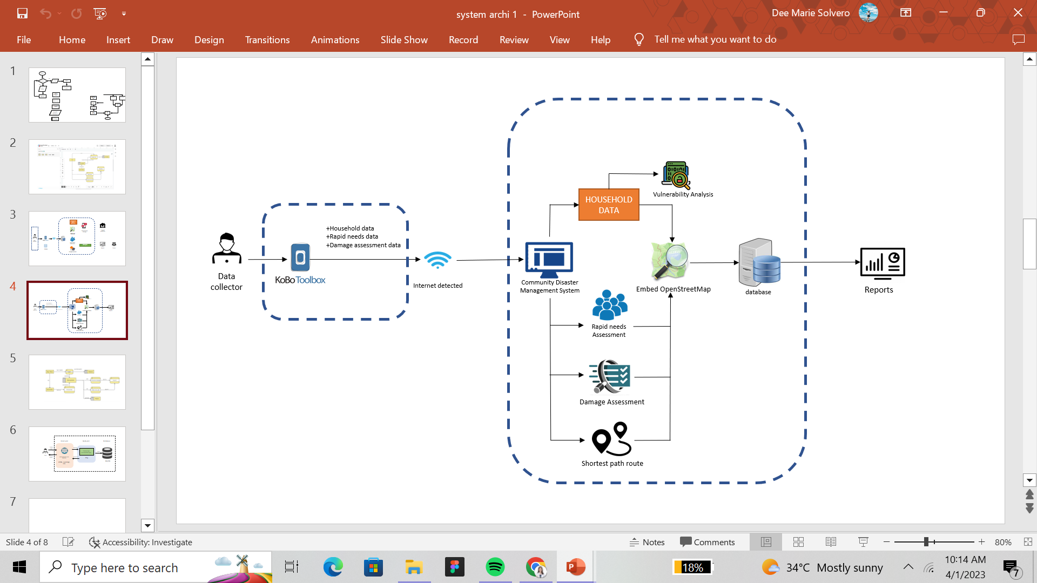

**Figure 1.** System Architecture

Database Design

Figure 2 shows the Entity Relationship Diagram of the system and the corresponding data needed for the rapid needs assessment and damage assessment reports. 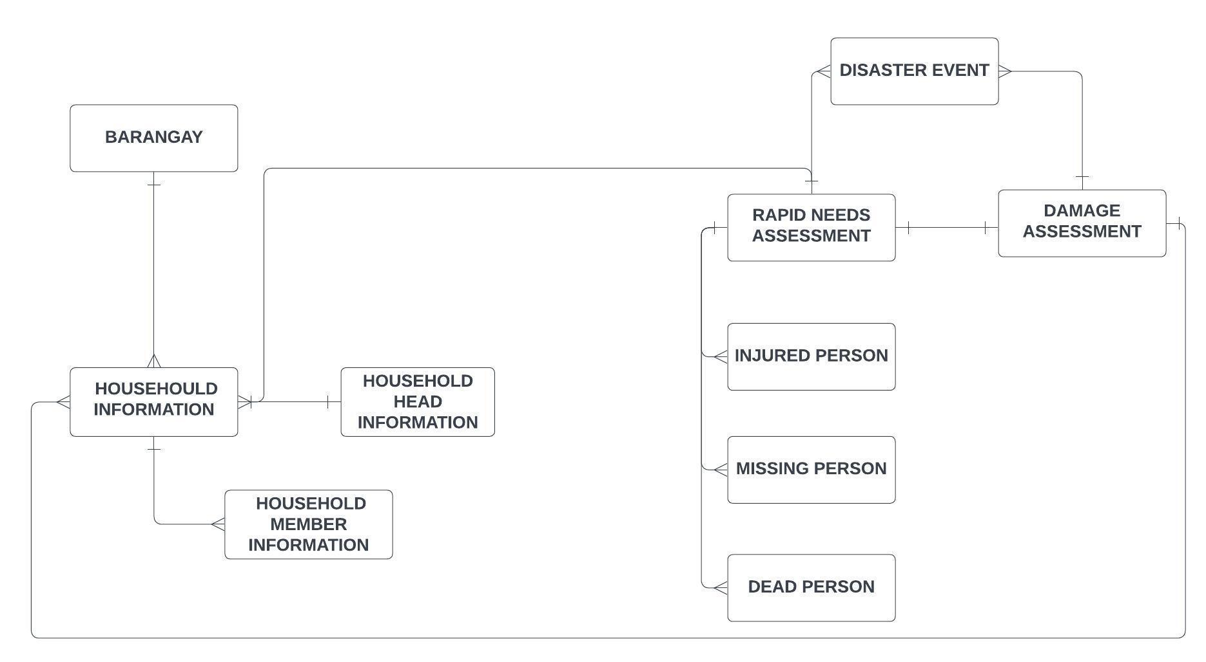

**Figure 2**. Simplified Entity-Relationship Diagram

**Table 1**

*Database Design of the Proposed System*

Barangay

|  |  |  |  |
| --- | --- | --- | --- |
| **BARANGAY** | **INTERVIEWER (PK)** | **PUROK_SITIO** | **BARANGGAY_PSGC** |
| Bonbon | Dee Marie Solvero | 1 | PH063025015 |
| Bonbon | Iszah Grace Solvero | 1 | PH063025015 |
| Bonbon | Von Chichirta | 1 | PH063025015 |

Household Information

|  |  |  |  |
| --- | --- | --- | --- |
| **HH_HOUSEHOLD_**  **NUMBER (PK)** | **HH_HOUSEHOLD_UNQ_ID** | **HH_ADDRESS** | **HH_OWNERSHIP** |
| 6 | PH063025015-6 | Bonbon | owned |
| 56 | PH063025015-56 | Bonbon | owned |
| 88 | PH063025015-88 | Bonbon | owned |

(cont,)

|  |  |
| --- | --- |
| **HH_CONSTRUCTION_MATERIALS** | **TOILET_USED** |
| Permanent (Mostly Concrete) | Open pit |
| Semi-Permanent (Combination of Concrete and Wood) | Water sealed |
| Semi-Permanent (Combination of Concrete and Wood) | Open pit |

|  |  |  |
| --- | --- | --- |
| **WITH_CONCRETE_SEPTIC_TANK** | **SOURCE_OF_WATER** | **SOURCE_OF_LIGHT** |
| Water sealed | Deep Well | Owned |
| Flushed sealed | Pumped owned | Owned |
| Water sealed | Deep Well | Owned |

|  |  |  |  |
| --- | --- | --- | --- |
| **HH_GEO_HAZARD** | **HH_GEO_HAZARD_TYPE** | **HH_LOCATION** | **HH_PHOTO** |
| Yes | Landslide Prone | Bonbon | photo.jpeg |
| No | Landslide Prone | Bonbon | pic.jpeg |
| No | Landslide Prone | Bonbon | p1.jpeg |

(cont,)

Household Head Information

|  |  |  |  |
| --- | --- | --- | --- |
| **HH_HEAD** | **HH_HEAD_NAME (PK)** | **HH_HEAD_AGE** | **HH_HEAD_SEX** |
| Ernesto Guanzon | Ernesto Guanzon | 36 | male |
| Manuel Guanzon | Manuel Guanzon | 40 | male |
| Henry Herera | Henry Herera | 29 | male |

|  |
| --- |
| **PRIMARY_CONTACT_NUMBER** |
| 9123789273 |
| 9888899991 |
| 9888896661 |

Household Member Information

|  |  |  |
| --- | --- | --- |
| **NAME_NUMBER** | **HH_INDIVIDUAL_UNQ_ID(PK)** | **HH_MEMBER_LAST_NAME** |
| Eunice | PH063025015-15-1-3 | Juanico |
| Eugine | PH063025015-34-1 | Franco |
| Manny | PH063025015-3-1 | Deasis |

(cont,)

|  |  |
| --- | --- |
| **HH_MEMBER_FIRST_NAME** | **HH_MEMBER_MIDDLE_NAME** |
| Henry | Mendiola |
| Loisa | Estancia |
| Kenn | Martinez |

|  |  |
| --- | --- |
| **HH_MEMBER_COMPLETE_NAME** | **HH_RELATIONSHIP_TO_HEAD** |
| Henry Mendiola Juanico | Father |
| Loisa Estancia | sister |
| Kenn Martinez | brother |

|  |  |  |
| --- | --- | --- |
| **HH_MEMBER_DOB** | **HH_MEMBER-AGE** | **HH_MEMBER_SEX** |
| 08-16-1988 | 35 | Male |
| 08-01-2001 | 21 | Female |
| 04-08-2005 | 16 | Male |

|  |  |
| --- | --- |
| **HH_MEMBER_MARITAL_STATUS** | **HH_MEMBER_DISABILITY_TYPE** |
| Married | None |
| Single | None |
| Single | None |

(cont,)

|  |  |  |
| --- | --- | --- |
| **HH_MEMBER_EDUCATION** | **HH_MEMBER_ALS** | **HH_MEMBER_SCHOOLING** |
| College graduate | 0 | 3 |
| College graduate | 0 | 0 |
| High School | 0 | 2 |

|  |  |
| --- | --- |
| **HH_MEMBER_SCHOOL_ATTENDANCE** | **HH_MEMBER_OCCUPATION** |
| 0 | Manager |
| 0 | Data analyst |
| 2 | DMO |

|  |  |
| --- | --- |
| **HH_MEMBER_MONTHLY_INCOME** | **IS_HH_MEMBER_FIRST_PRIMARY_**  **INCOME_EARNER** |
| 50,000 | yes |
| 80,000 | yes |
| 10,000 | yes |

|  |
| --- |
| **HH_MEMBER_PHILHEALTH** |
| 0 |
| 0 |
| 0 |

(cont,)

Disaster Event

|  |  |  |  |
| --- | --- | --- | --- |
| **DISASTER_EVENT_ID** | **DISASTER_EVENT (PK)** | **TYPE_OF_DISASTER** | **DATE_AND_TIME_OF_**  **OCCURRENCE** |
| 19 | Danny | Typhon | 2022-08-19T05:00:00+08:00 |
| 20 | Danny | Typhon | 2022-08-19T05:00:00+08:01 |
| 21 | Danny | Typhon | 2022-08-19T05:00:00+08:02 |

Rapid Needs Assessment

|  |  |  |
| --- | --- | --- |
| **INTERVIEWER** | **HOUSEHOLD_NUMBER** | **HOUSEHOLD_HEAD** |
| Dee Marie Solvero | 1025 | Mariano Lopez |
| Iszah Grace Solvero | 1030 | Grace Percia |
| Von Chichirta | 1001 | Victor Nelson |

|  |  |
| --- | --- |
| **DID_THE_HOUSEHOLD_EVACUATE** | **PICTURE (PK)** |
| Yes | photo1.jpeg |
| Yes | phot02.jpeg |
| Yes | photo03.jpeg |

(cont,)

Injured Person

|  |  |  |  |
| --- | --- | --- | --- |
| **INJURED_PERSON_ID** | **LAST_NAME_001** | **FIRST_NAME_001** | **GENDER_001** |
| 20 | Lasconia | Haze | Female |
| 21 | Siva | Nico | Male |
| 22 | Parcia | Louisa | Female |

|  |  |  |  |
| --- | --- | --- | --- |
| **AGE_001** | **PWD_001** | **TYPE OF INJURY** | **PICTURE_001 (PK)** |
| 16 | Yes | laceration | photo.jpeg |
| 13 | No | abrasion | photo2.jpeg |
| 12 | No | head injury | photo3.jpeg |

Missing Person

|  |  |  |  |
| --- | --- | --- | --- |
| **MISSING_PERSON_ID** | **LAST_NAME_** | **FIRST_NAME** | **GENDER** |
| 1 | Dejaro | Rowena | Female |
| 2 | Andalo | Loisa | Female |
| 3 | Aguila | Noryl | Female |

|  |  |  |
| --- | --- | --- |
| **AGE** | **PART_OF_DAP_S** | **PICTURE(PK)** |
| 39 | yes | photo.jpeg |
| 4 | no | photo2.jpeg |
| 13 | no | photo3.jpeg |

(cont.)

Dead Person

|  |  |  |  |
| --- | --- | --- | --- |
| **DEAD_PERSON_ID** | **LAST_NAME_002** | **FIRST_NAME_002** | **GENDER_002** |
| 13 | Juarez | Nea | Female |
| 14 | Gingo | Jin | Female |
| 15 | Parcon | Manny | Male |

|  |  |  |  |
| --- | --- | --- | --- |
| **AGE_002** | **PART_OF_DAP_S_002** | **CAUSE_OF_DEATH** | **PICTURE_002** |
| 89 | No | Heart attack | photo.jpeg |
| 12 | No | Inner wound | photo2.jpeg |
| 67 | No | Heart attack | photo3.jpeg |

Damage Assessment

|  |  |  |
| --- | --- | --- |
| **INTERVIEWER (FK)** | **HOUSEHOLD_NUMBER** | **NAME_OF_HOUSEHOLD_HEAD** |
| Dee Marie Solvero | PH063025015-3 | Eunice Solvero |
| Iszah Grace Solvero | PH063025015-90 | Marshall Solvero |
| Von Chichirta | PH063025015-14 | Dennise Chichirta |

(cont.)

|  |  |  |
| --- | --- | --- |
| **TYPE_OF_INFRASTRUCTURE** | **PICTURE (PK)** | **TYPE_OF_DAMAGE** |
| House | photo.jpeg | partially damage |
| House | photo2.jpeg | partially damage |
| House | photo3.jpeg | partially damage |

|  |
| --- |
| **LOCATION_OF_DAMAGED_FACILITY** |
| Bonbon |
| Bonbon |
| Bonbon |

(cont.)

Procedural Design

Figure 3 shows the procedural design that visualizes how the system will perform when a certain activity is done. It shows the features of the systems and the embedded tools that the system will be using. A user must sign in and fill up their basic information. After logging in, they will be directed to the platform. First, there will be a household data module where it can generate reports with an embedded map from OpenStreetMap. The rapid needs assessment and damage assessment also generates reports based on the data that has been encoded in KoboToolbox. There is also a short path route for the distribution of goods to the vulnerable population. By clicking in the start point and end point location it can calculate the shortest distance between the locations for the faster distribution of the goods.

**Figure 3.** Procedural Design (Login)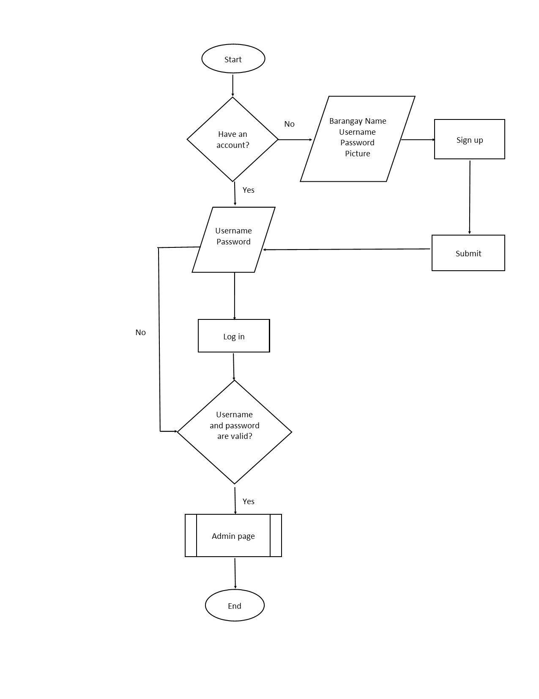

(cont.)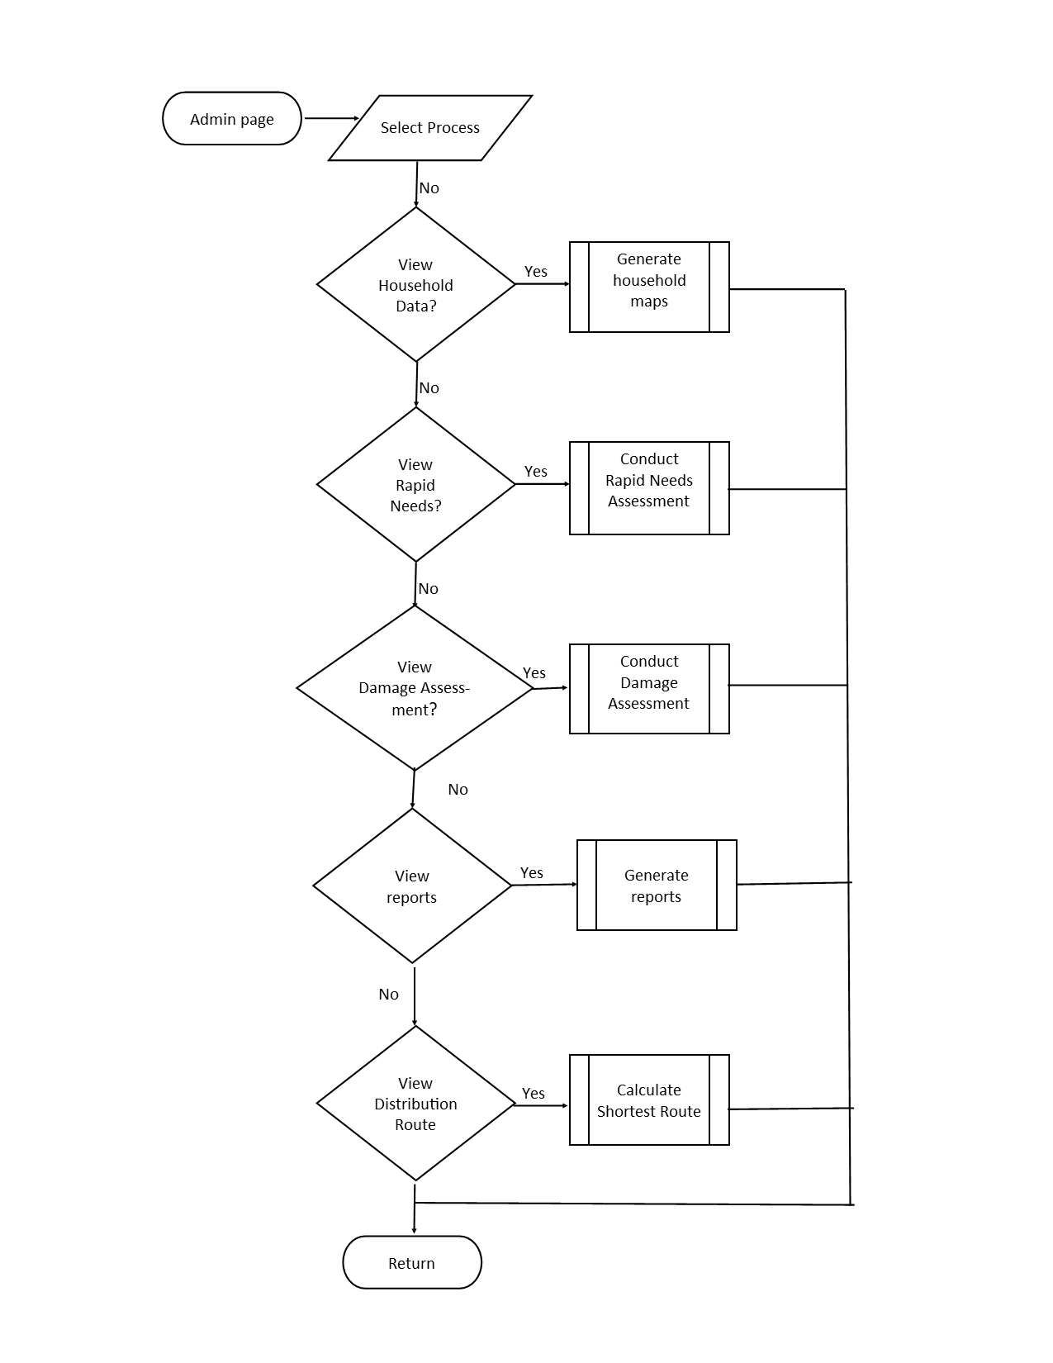

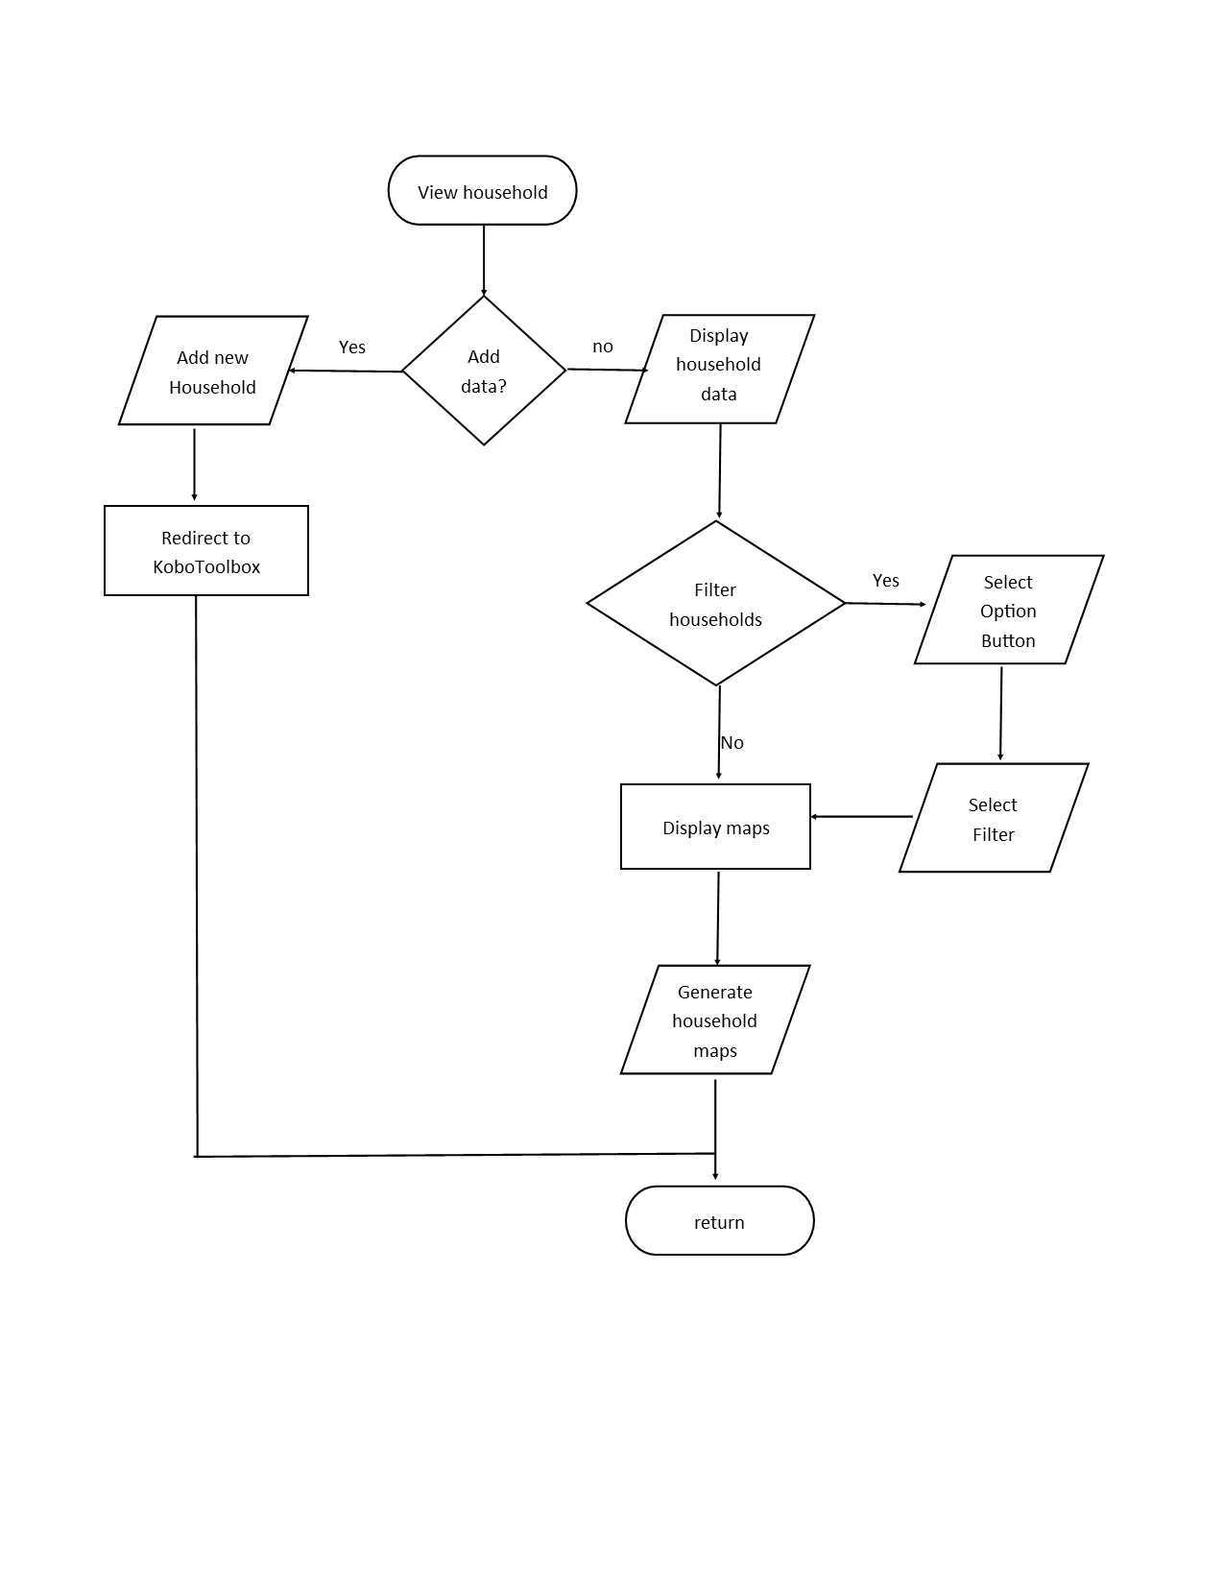

(cont.)

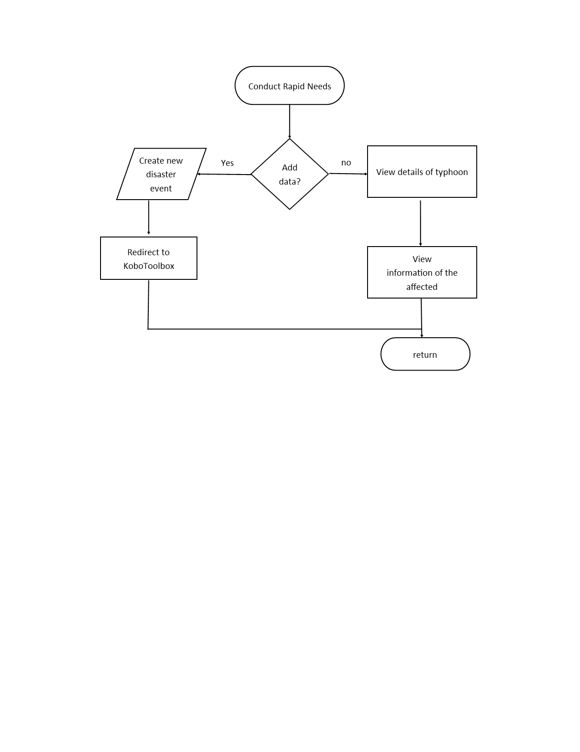

(cont.)

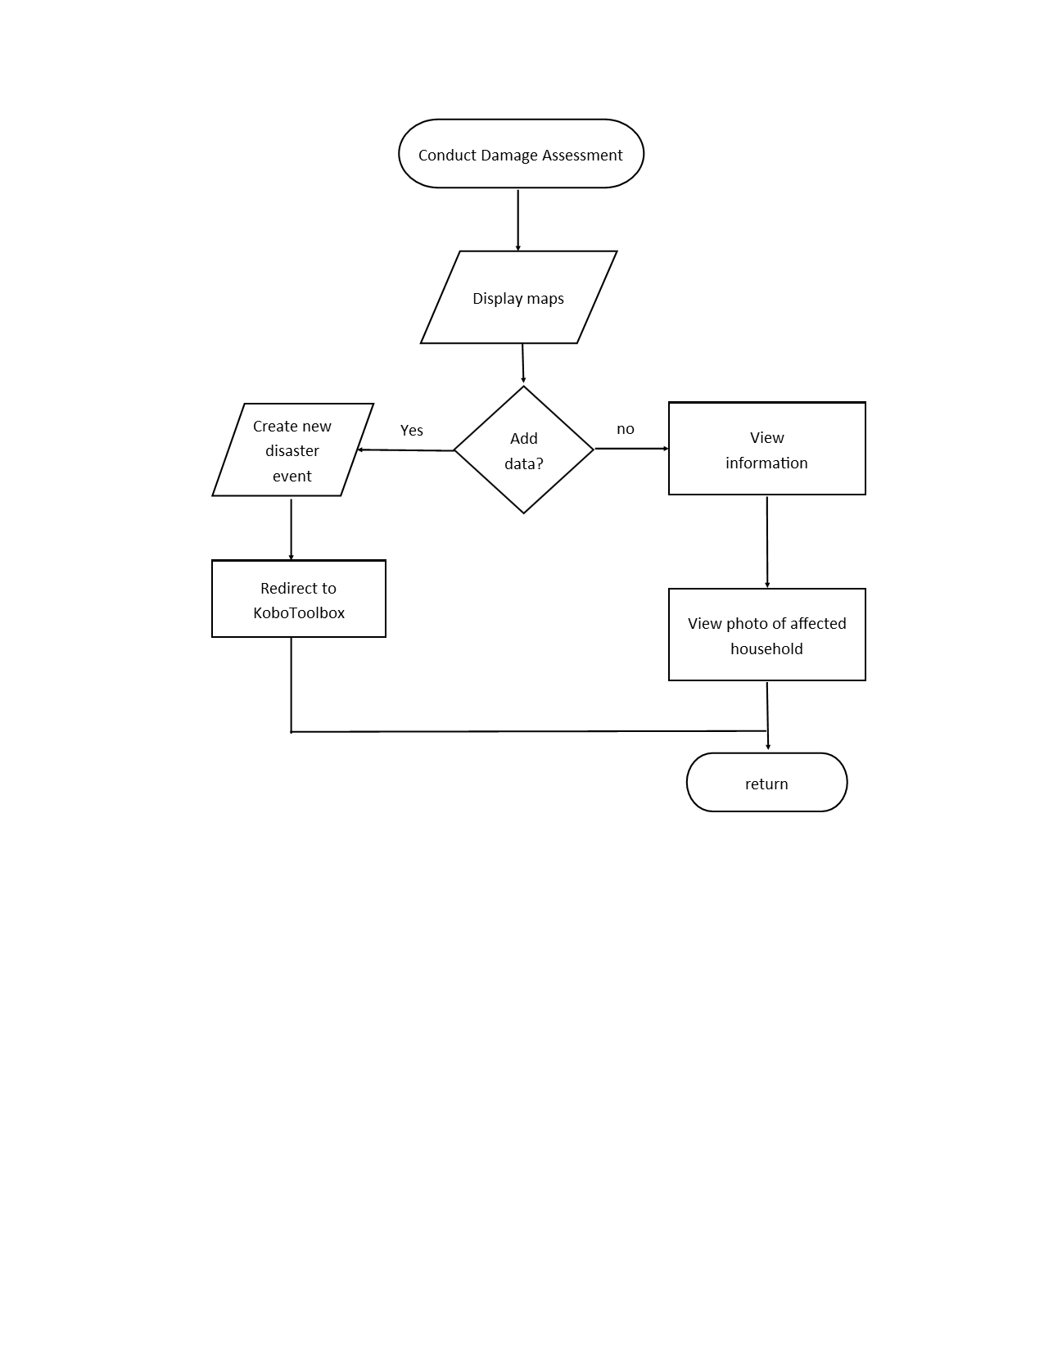

(cont.)

(cont.)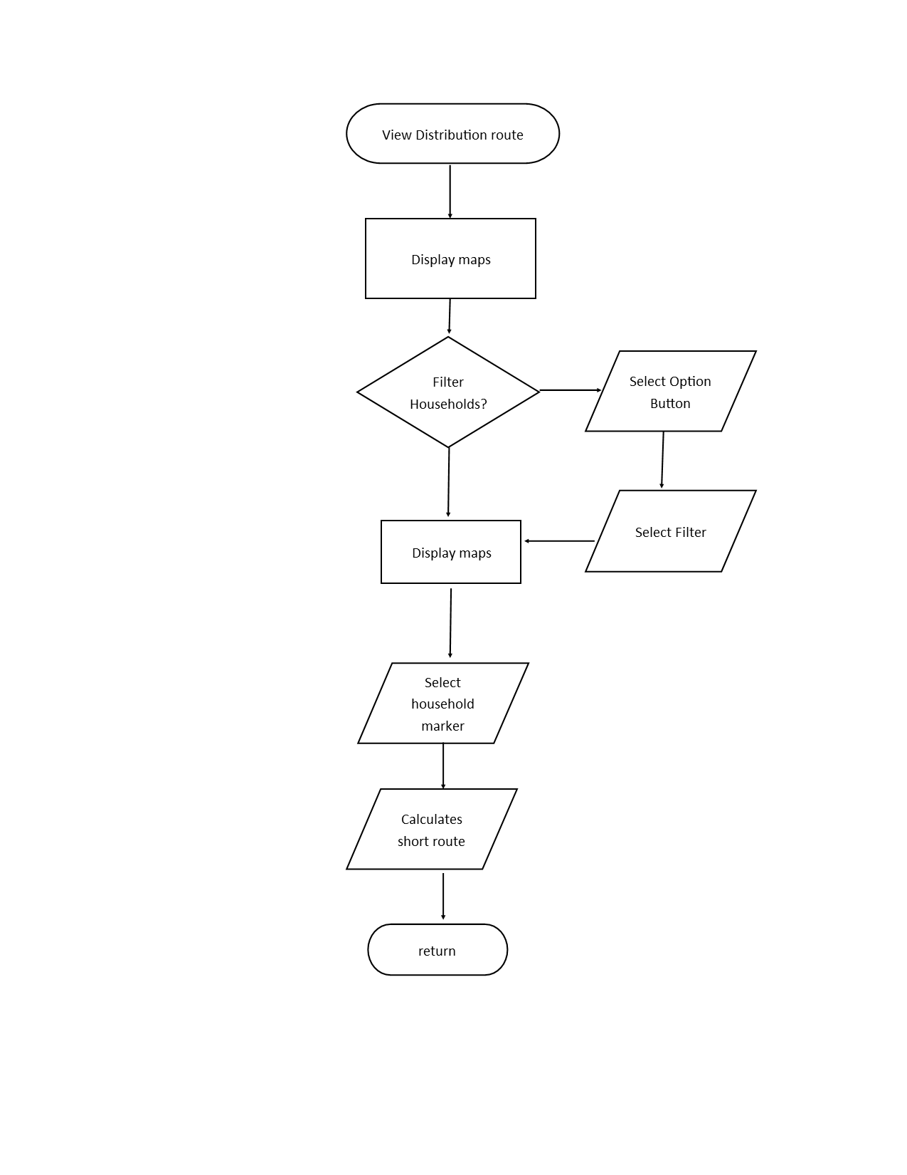

(cont.)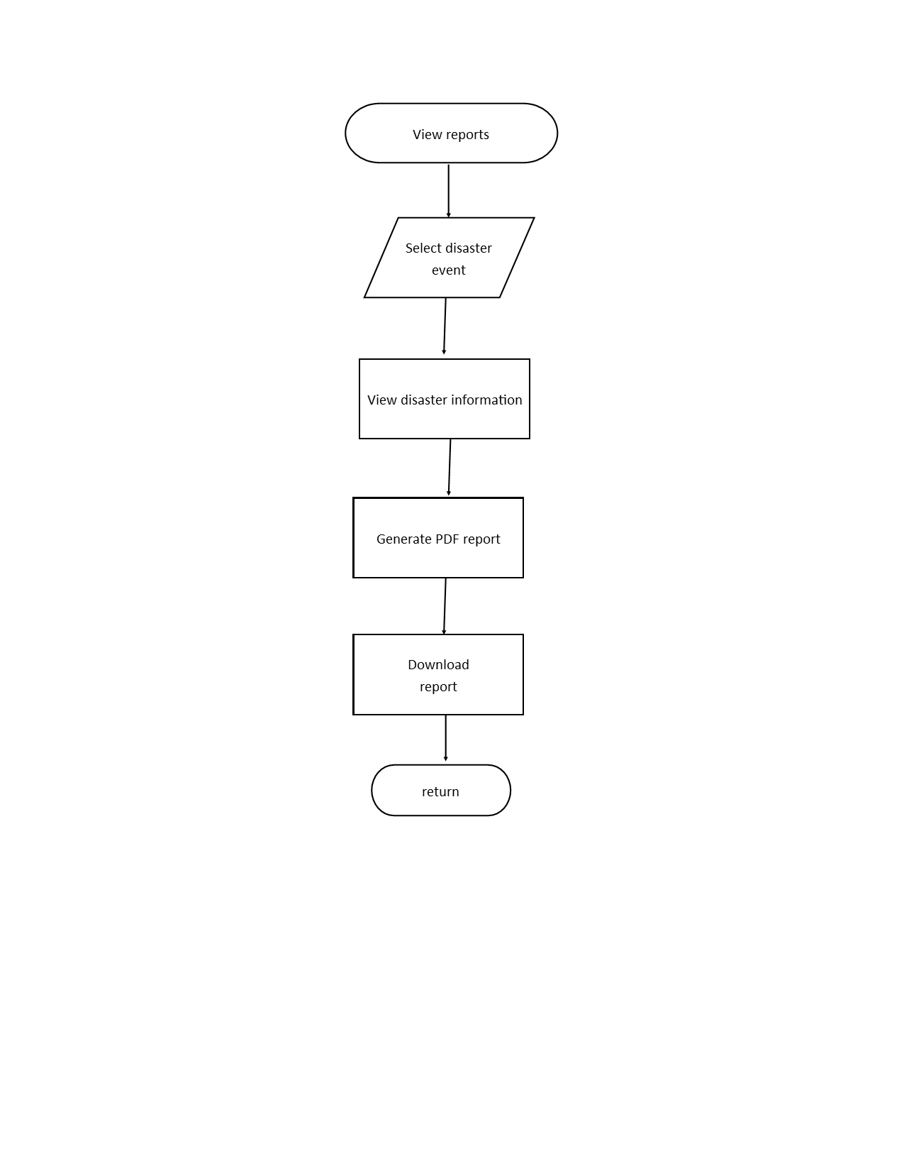

Process Design using Data Flow Diagram

Figure 4 and 5 shows how the data will flow in the systems. The process will start by inputting the data that have been collected in the KoboToolbox. The data that have been inputted will be stored in the KoboToolbox first, and after that, the system will process the data to generate outputs and reports. Same process will be implemented in household information, rapid needs and damage reporting.

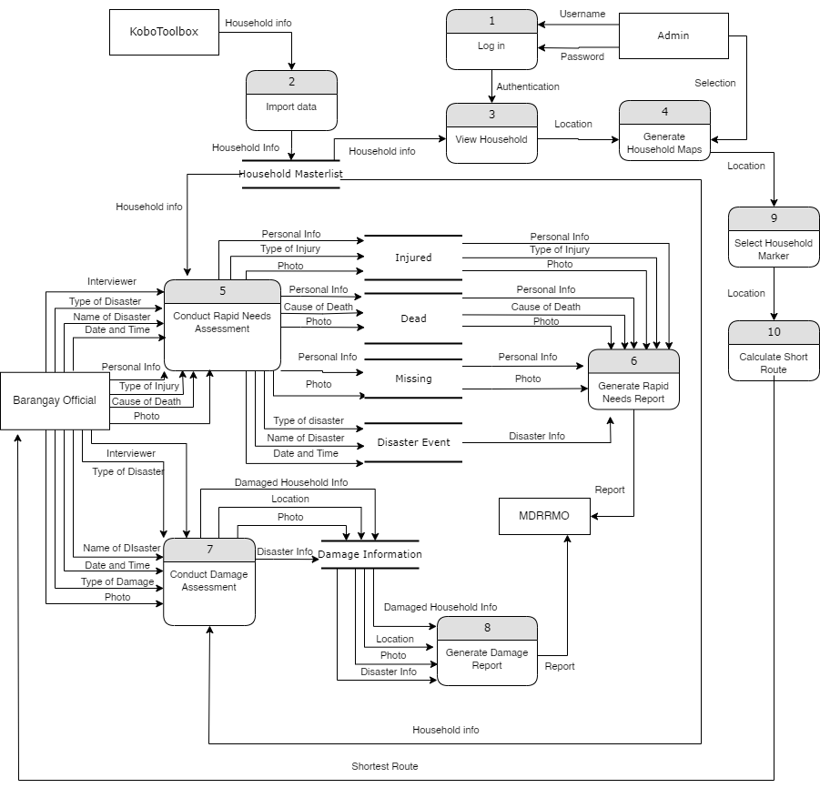

**Figure 4.** Data Flow Diagram (Level 0)

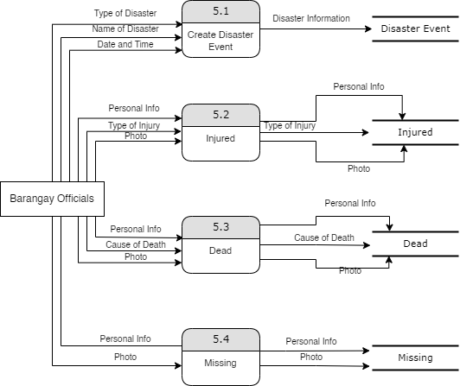

**Figure 5.** Data Flow Diagram Level 1

(Conduct Rapid Needs Assessment)

Use-Case Diagram

Figure 6 shows the graphical representation of possible user interactions with the system. A use case diagram, which is frequently complemented by other types of diagrams, displays the numerous use cases and user types the system has. It illustrates and defines the context and requirements of either an entire system or the important parts of the system. It also helps with the identification of any internal or external factors that might affect the system and must taken into consideration.

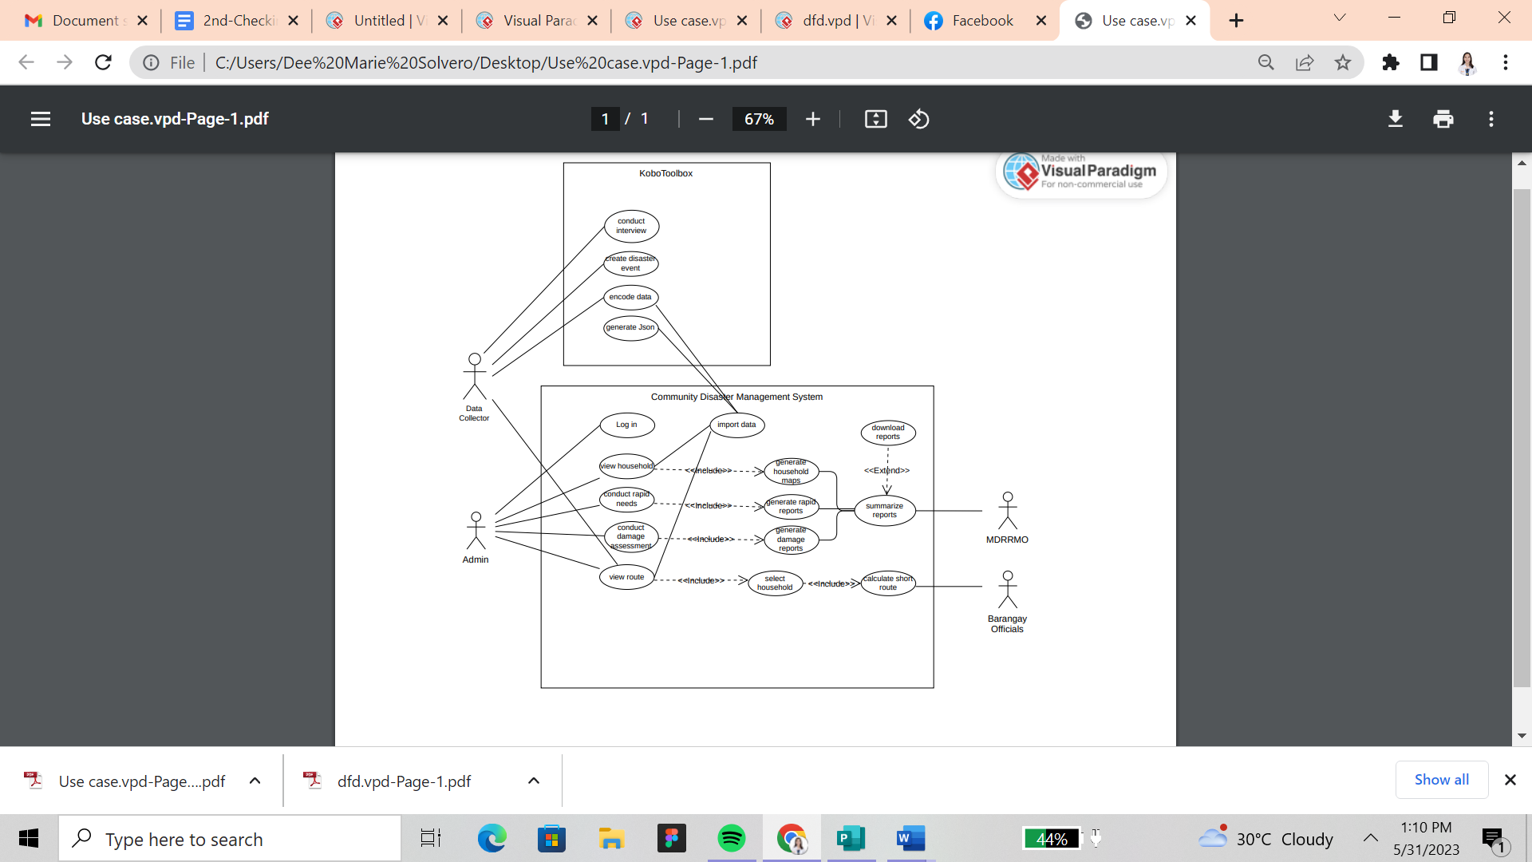

**Figure 6.** Use-Case Diagram

Methodology

The Waterfall Methodology was utilized for the development of the system. The process is conducted iteratively until the specific goals are achieved. This method consists of several phases that are open to adaptation and changes even if it goes through several phases. This involves analysis, requirement specification, design, development, testing and integration, implementation/ deployment.

In the analysis process phase, a research area is identified to determine the problem and the specific needs and resources of the certain topic. The researchers studied the process of a Barangay Officials in a community on how they assess the affected population, households and its damage in the community when a disaster arises. Specific needs, resources and data will be gathered to develop a design for the user interface by conducting preliminary interviews to the said community. The development phase involves the actual writing of the program or the coding process that includes other tasks. It is the process to integrate the Openstreetmap, and KoboToolbox that will be needed in the system. The testing stage is where the system will be evaluated to test its effectiveness, and ensures that each function works correctly to pass the requirements for deployment.

The release stage or deployment is to integrate the community disaster management system that will provide a localized early warning system through SMS, rapid needs assessment and damage reporting. The system's performance will be evaluated and also be tested by the research panels to ensure the functionality and usability of the system.

**Figure 7.** System Development Life Cycle 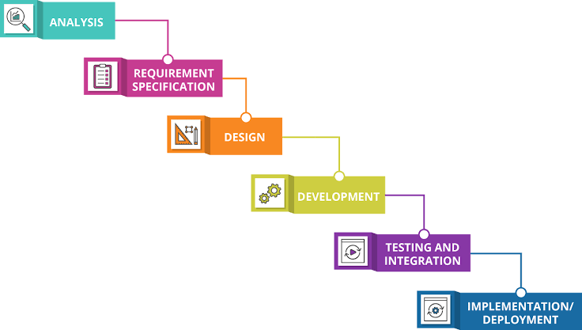

(Waterfall Methodology)

CHAPTER 4 RESULTS AND DISCUSSION

Implementation

In the preparation phase, the data collector needs to gather the household data from the barangay and encode it in KoboToolbox. After encoding the data, it created a disaster event and proceeded with rapid assessment and damage assessment data. After that, the system was able to assess the data. Response and recovery were able to take place for those who are affected by the disaster.

The system was implemented mainly to monitor the household in the community and assess the rapid needs and damages to infrastructure of the affected household. The system was implemented by means of actual and thorough demonstration to test the effectiveness, functionality, usability and to determine the reliability of the system. The gathering of the data and the integration of the SMS where the challenges as the researchers collaborated with the MDRRMO and the community to have enough resources to implement the system. The system was able to integrate the Kobotoolbox API and import data into the system. It was able to generate maps and shortest paths. However, there were challenges in terms of generating the functionality for broadcasting SMS.

By assessing and consolidating the data, the researchers learned that the current system of the MDRRMO and the community was still in a traditional set up in terms of its process in collecting the data of the affected persons in times of disaster. Those collected data served as the basis of the researchers to fully implement the system. The analysis and hypotheses were clearly documented and implemented in the system. All of the general functionalities were automated and supported by the system.

The development process of the system went successfully through the phases of the Waterfall method which are: analysis, requirement specification, design, development, testing, and implementation. After gathering and analyzing the needed information, the researchers came up with the user interface to visualize what the system would look like, and decided on the development tools. The researchers used Sublime Text for the IDE and XAMPP for the hosting. The programming language was PHP and JavaScript for the backend while HTML and CSS for the frontend. The finished system was tested and ran many times to ensure the functionality of the components of the system. After completing the system, the system was subjected to user evaluation and was presented using a demo video. Means were employed in this study as the data gathered from the user evaluation were subjected to appropriate descriptive statistics.

*System Inputs and Outputs*

The proposed system is a Community Disaster Management System with rapid assessment and damage reporting that can help lessen the affected communities and prepare them for the upcoming disaster. This must be deployed on a desktop with an installed web server.

The system has only one user, specifically the admin or the assigned barangay official to manage the system. The data collectors have a privilege to edit, calculate routes, generate reports and monitor the maps of the households. Lastly, they must have logged in the KoboToolbox and downloaded the KoboCollect application in their mobile phones for them to collect the data.

KoboToolbox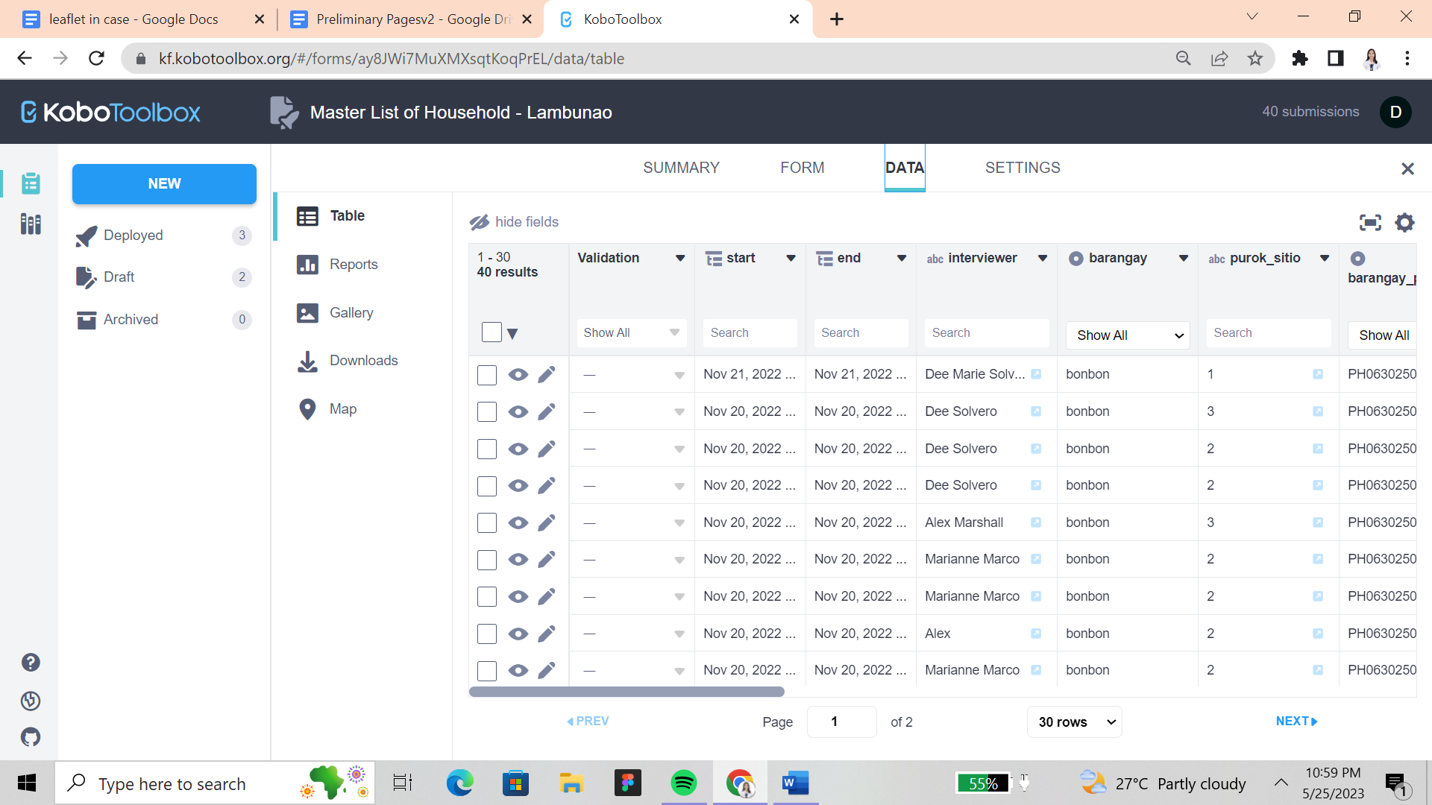

**Figure 8.** KoboToolbox

Figure 8 shows the KoboToolbox application used by the data collectors where the data was collected and stored. The users need to create an account to utilize and manage the assessment form for data collection. The need to download the KoboCollect application to utilize the forms.

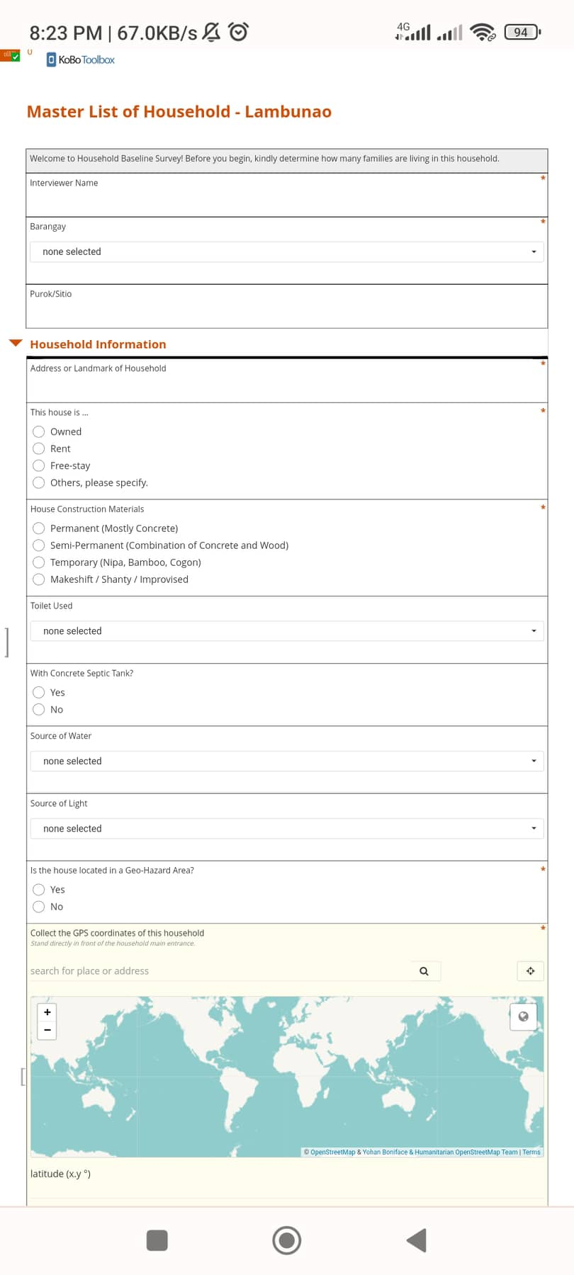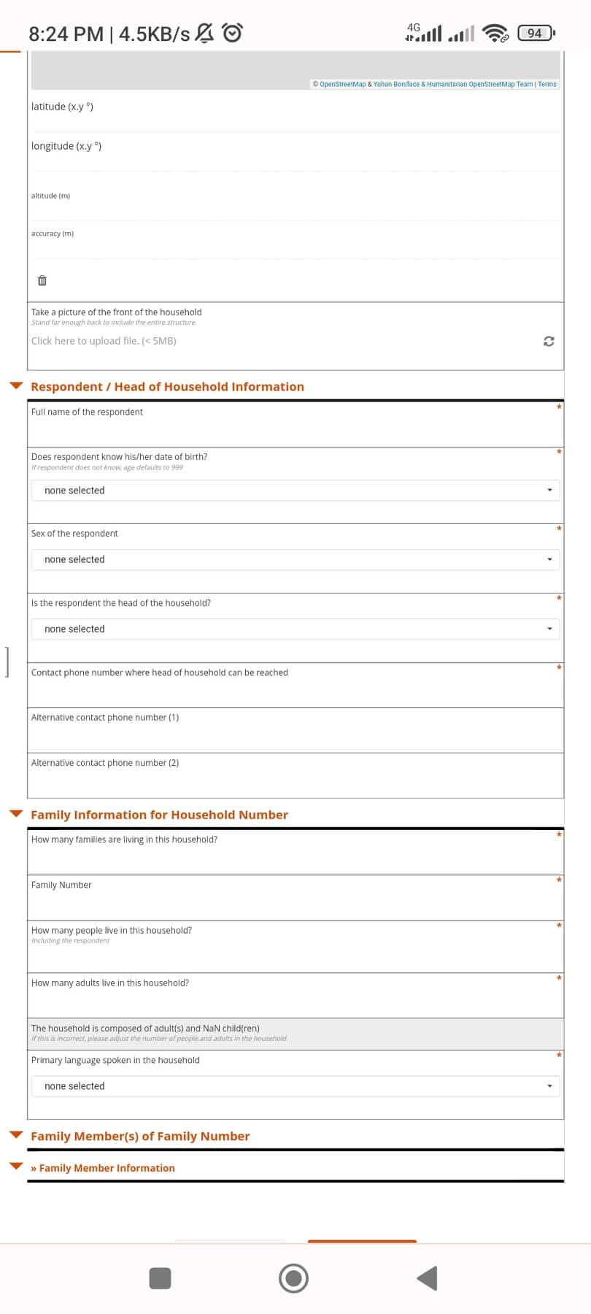

**Figure 9.** Household Information Form

Figure 9 shows the household information form where the data collector can input the information of the household. It also includes a form to determine who is the head of the household, family information for household number, and family member information.

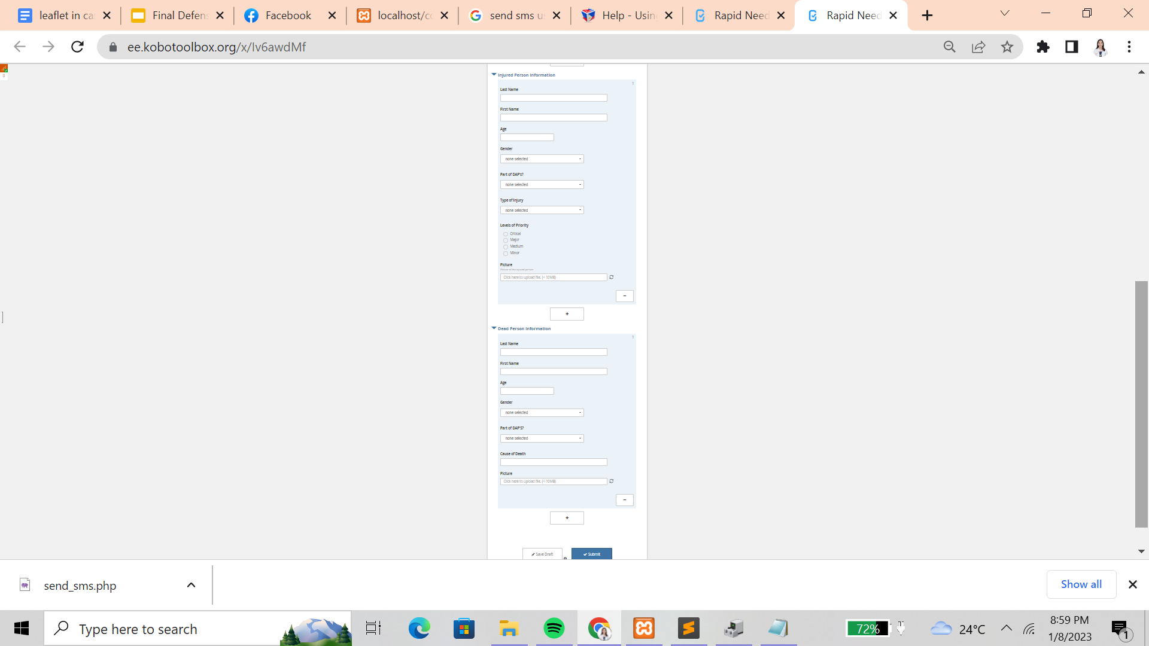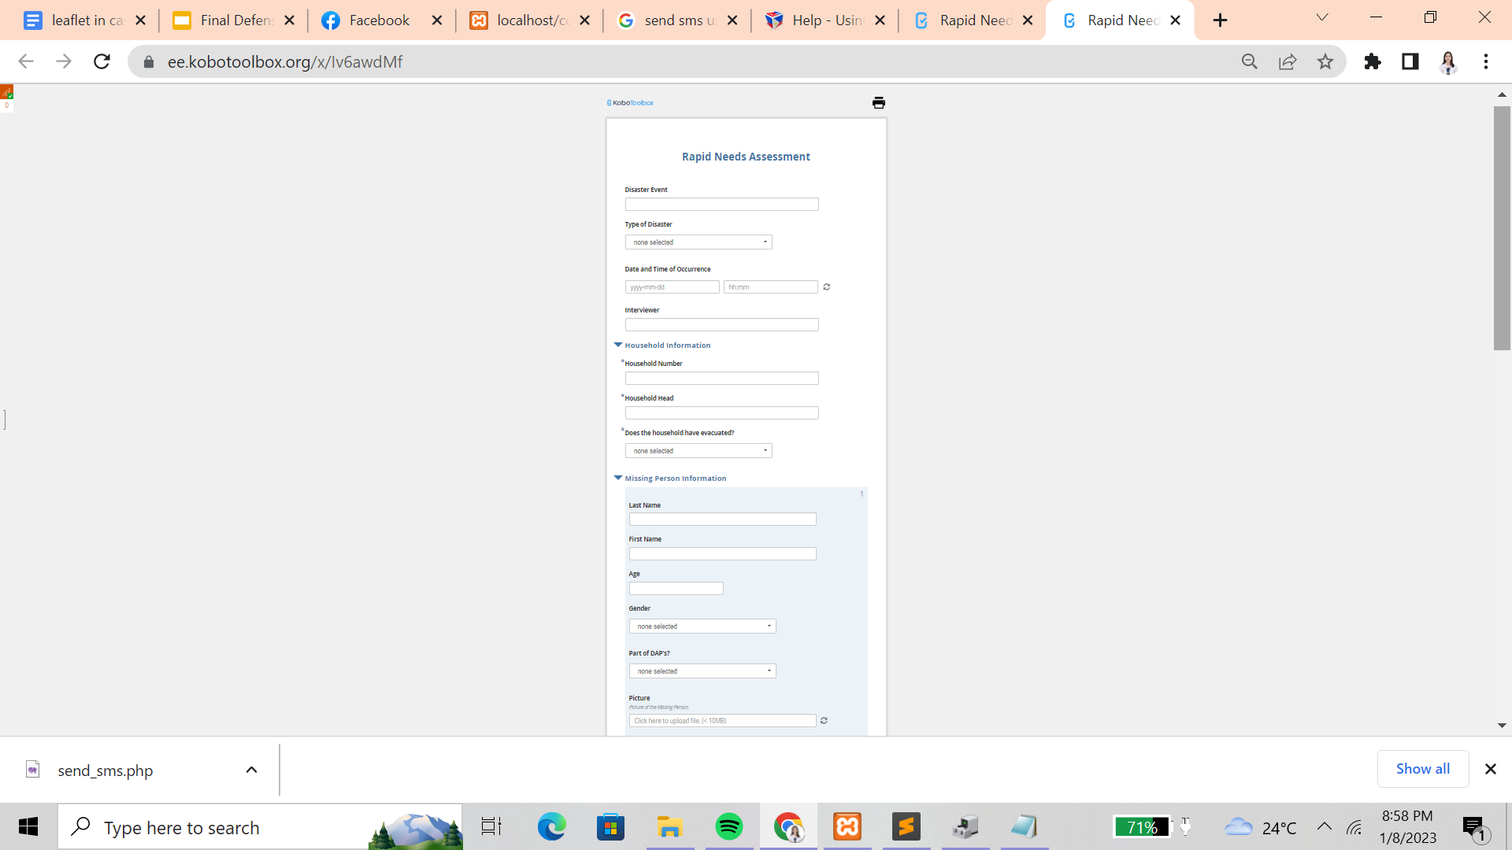

**Figure 10.** Rapid Needs Assessment Form

Figure 10 shows the rapid needs assessment form where data collectors can input the disaster event and what type of disaster has occurred, when did it happen, and the household information such as the household number, who is the head of the household, and their evacuation status. It also shows a data form to input the information of the missing, injured, and dead household members.

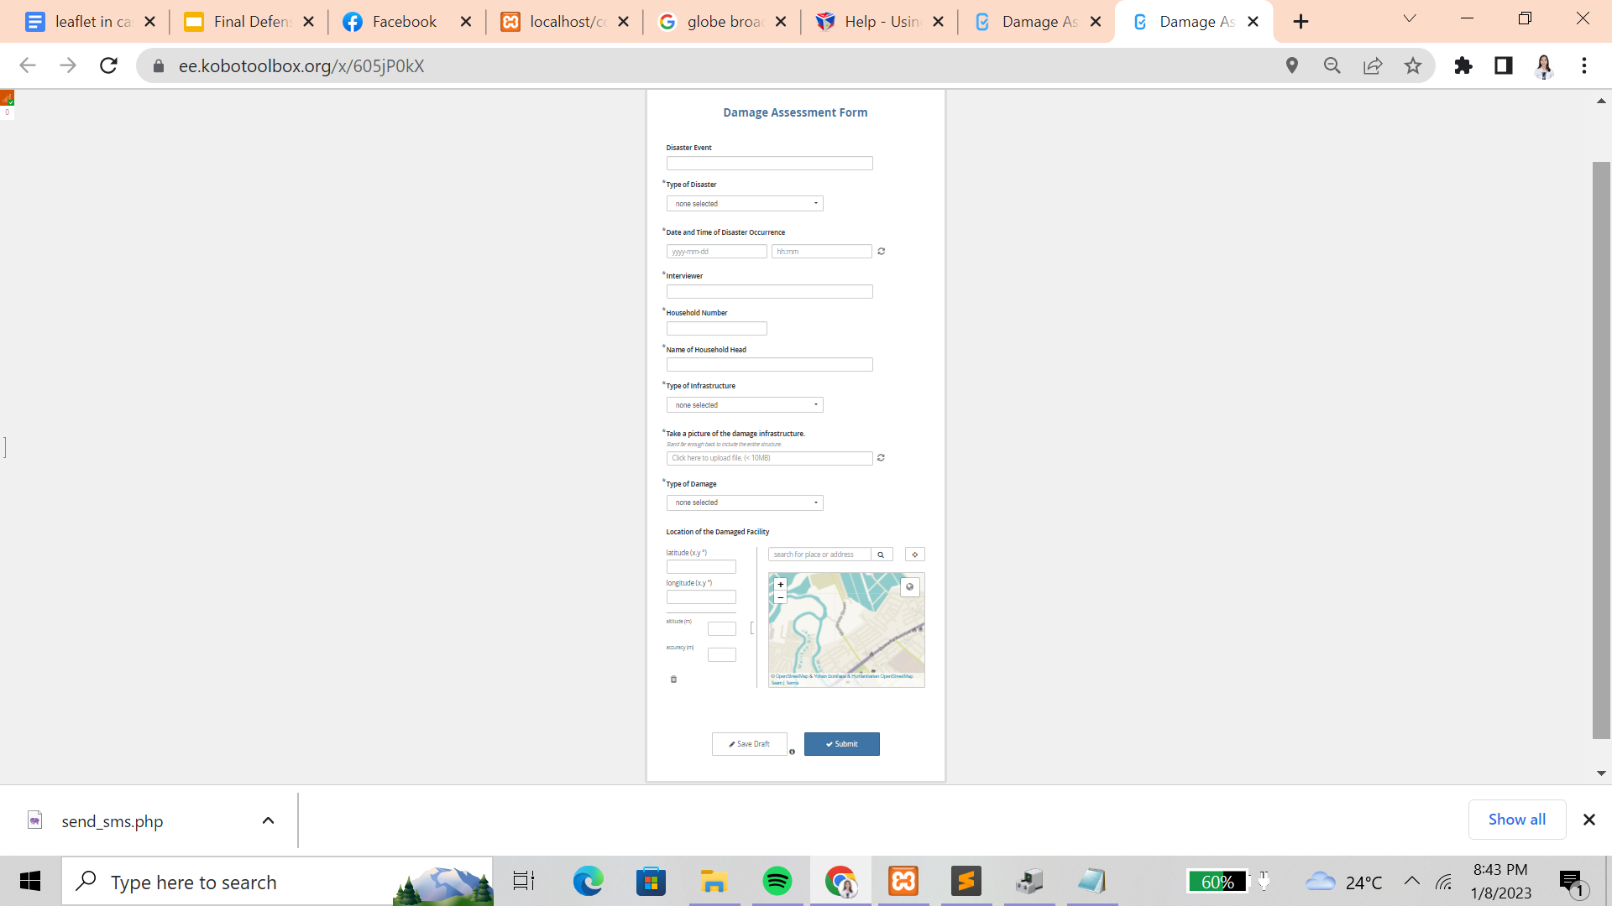

**Figure 11.** Damage Assessment Form

Figure 11 shows the damage assessment form where data collectors can input what type of disaster event occurs, when it happens, who are involved in the event, what type of infrastructure is damaged and a picture must be uploaded to assess its damages.

Community Disaster Management System

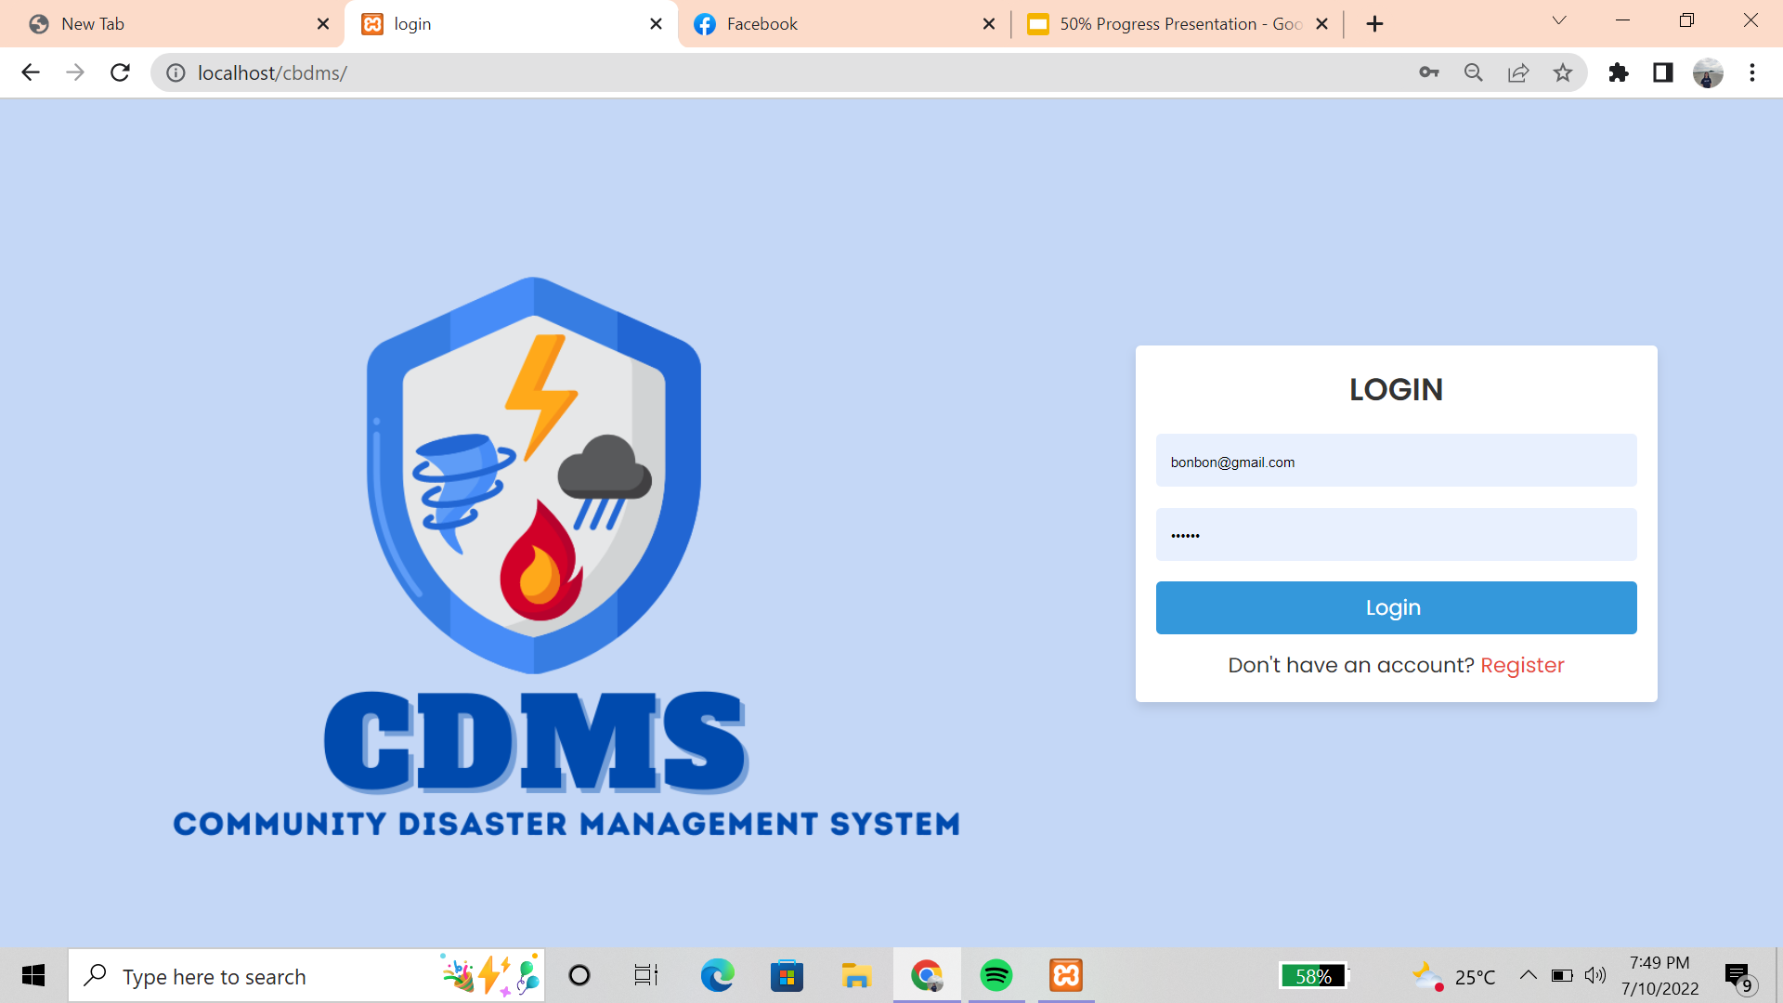

**Figure 12.** Log in

Figure 12 is the first screen to appear after opening the website which is the Login and register page.

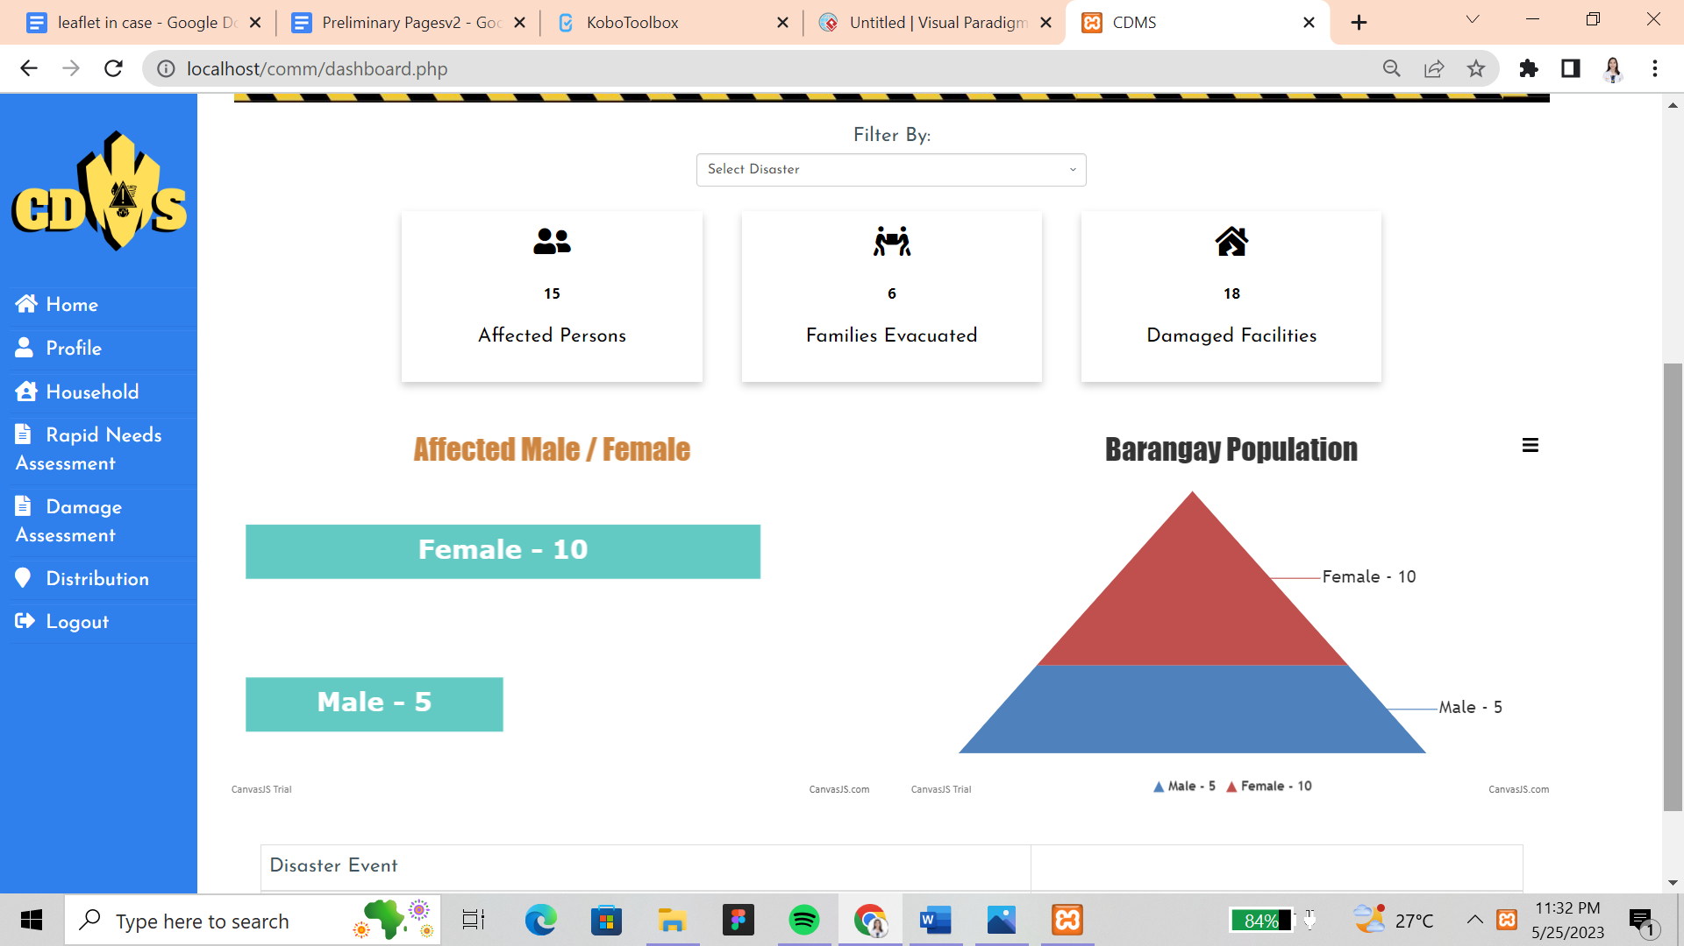

**Figure 13.** Dashboard

Figure 13 shows the count and charts of reported data in rapid needs and damage assessments.

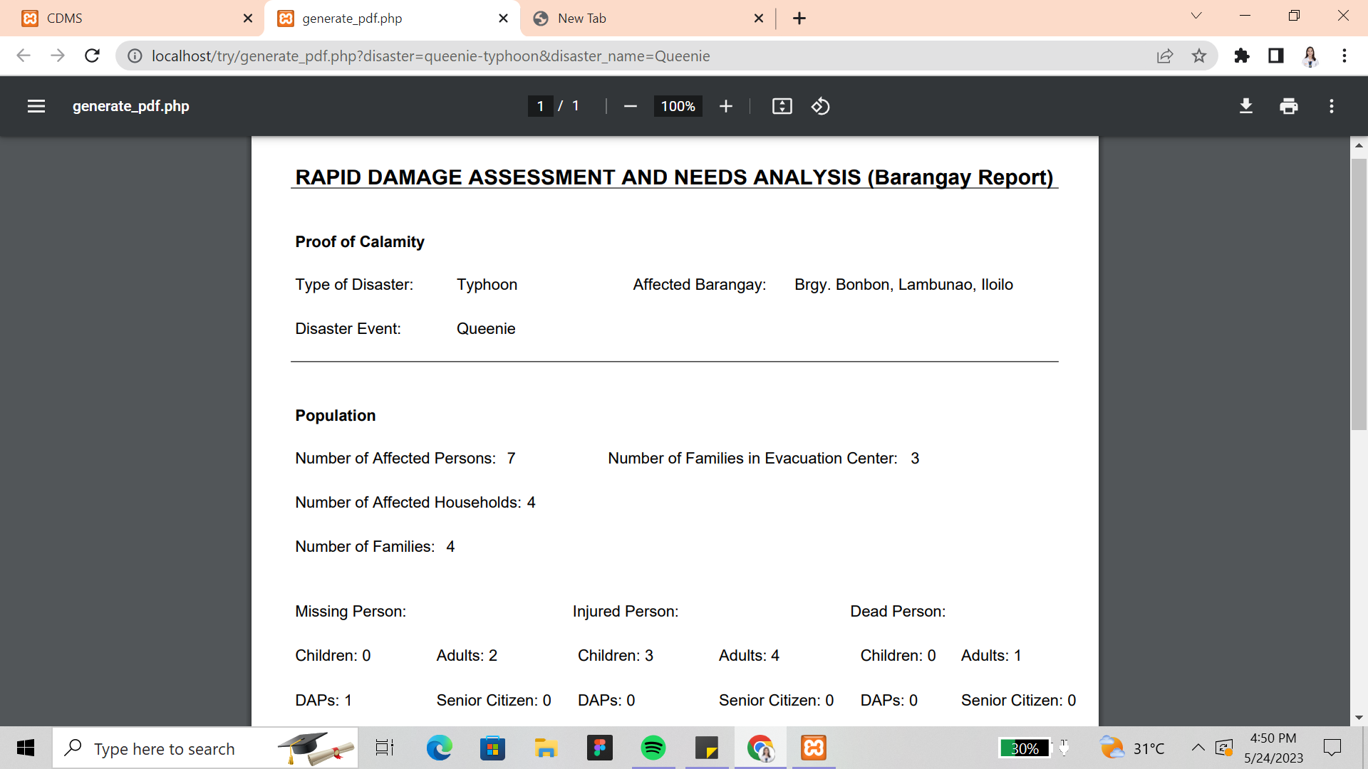

**Figure 14.** Reports

Figure 14 shows the summarized reports of rapid and damage assessment of a disaster in a pdf file. It can be downloaded and submitted to the LGU.

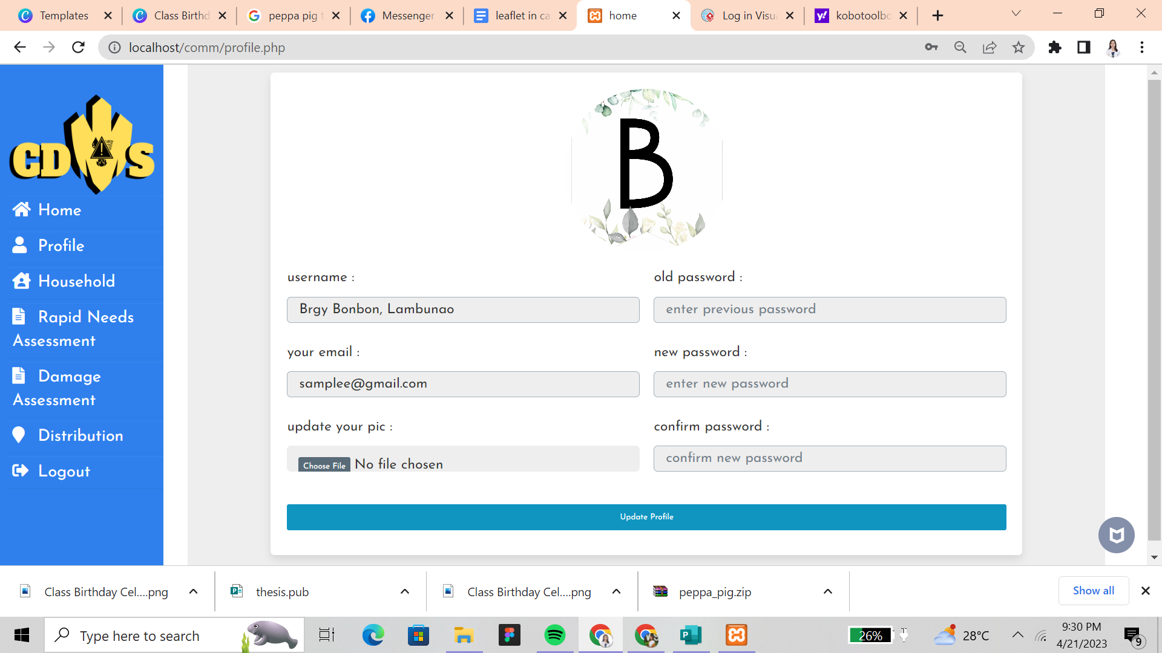

**Figure 15.** Profile

Figure 15 shows the basic information of the user and their information and picture can be updated.

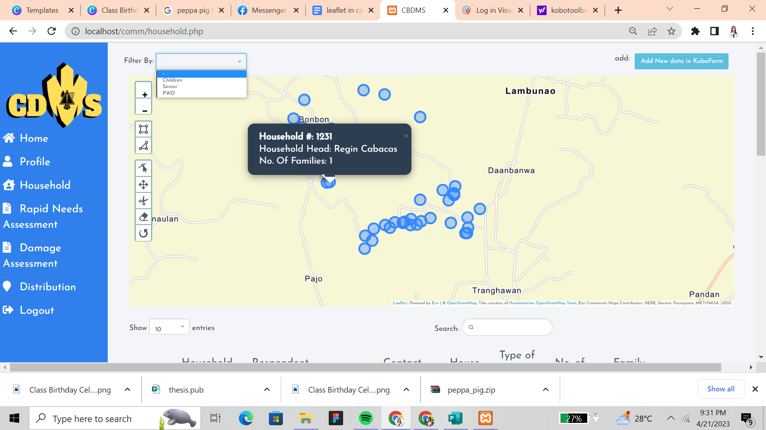

**Figure 16.** Household Tab

Figure 16 shows the household tab that monitors the household information and the mapping of their respective houses.

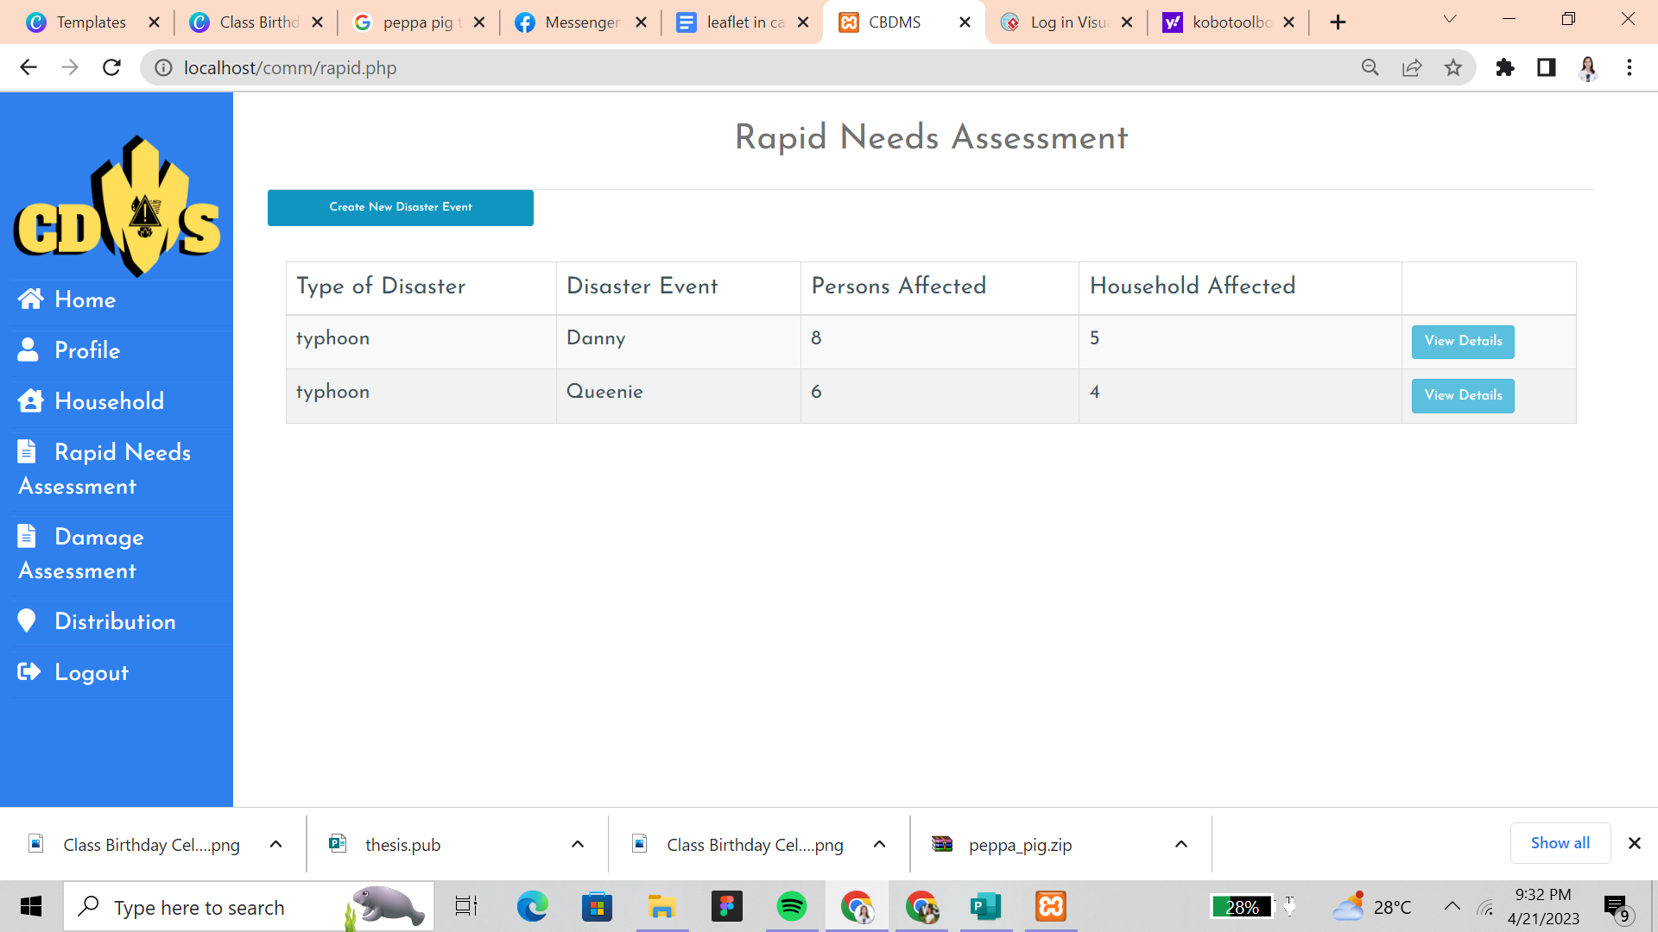

**Figure 17.** Rapid Needs Assessment

Figure 17 shows the rapid needs assessment tab where it displays information of what kind of disaster occurred where the user can view all the information of the recorded disaster such as what type of disaster occurred and how many households and persons are affected.

**Figure 18.** View Details (Rapid Needs Assessment)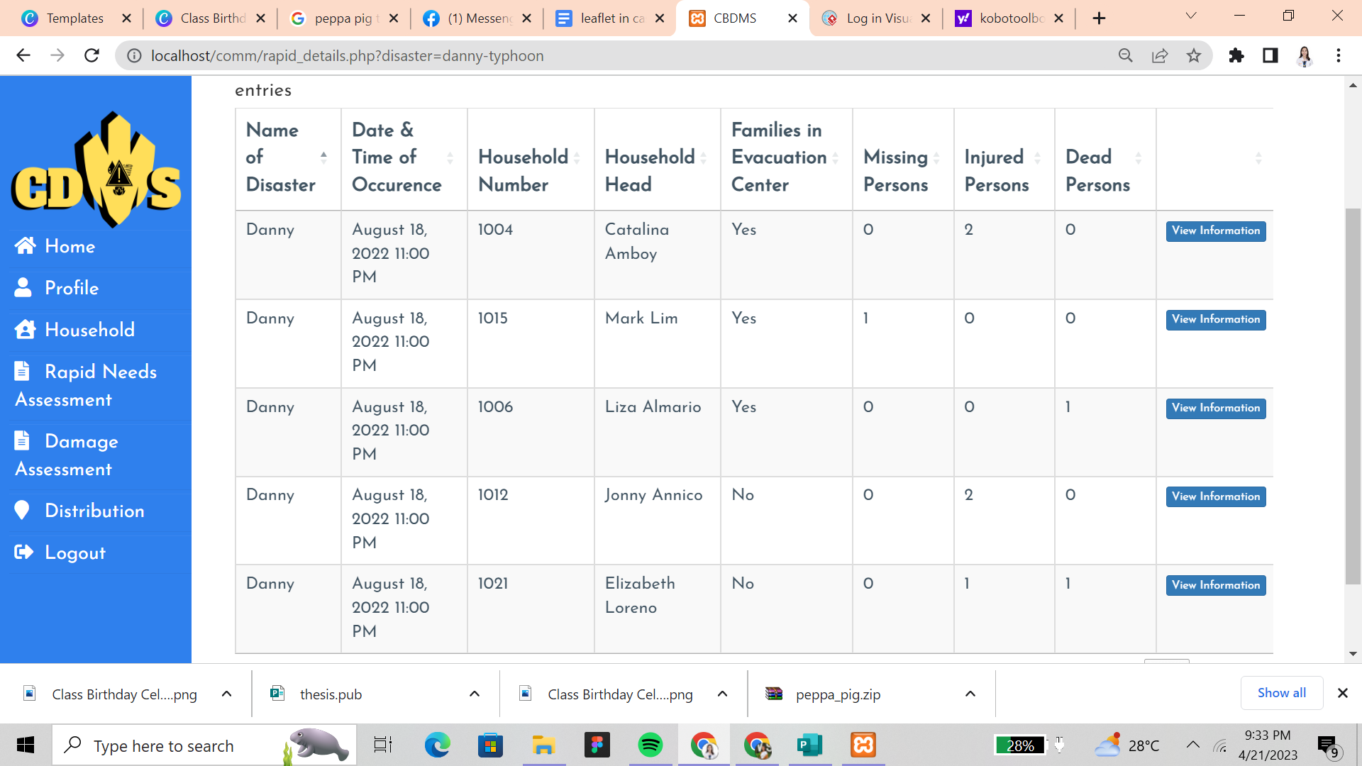

There is a View Details tab which can lead the user to see the information of the affected households and their evacuation status.

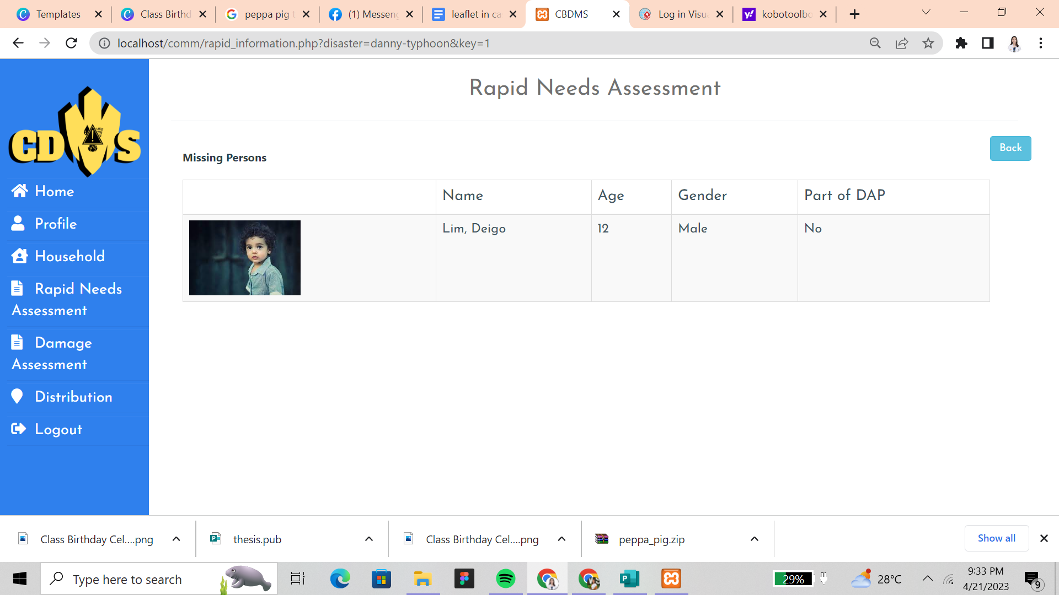

**Figure 19.** View Information Tab (Rapid Needs Assessment)

Figure 19 shows an option for the user where they can click the View Information tab to see the information of affected persons such as Missing, Injured, and Dead persons.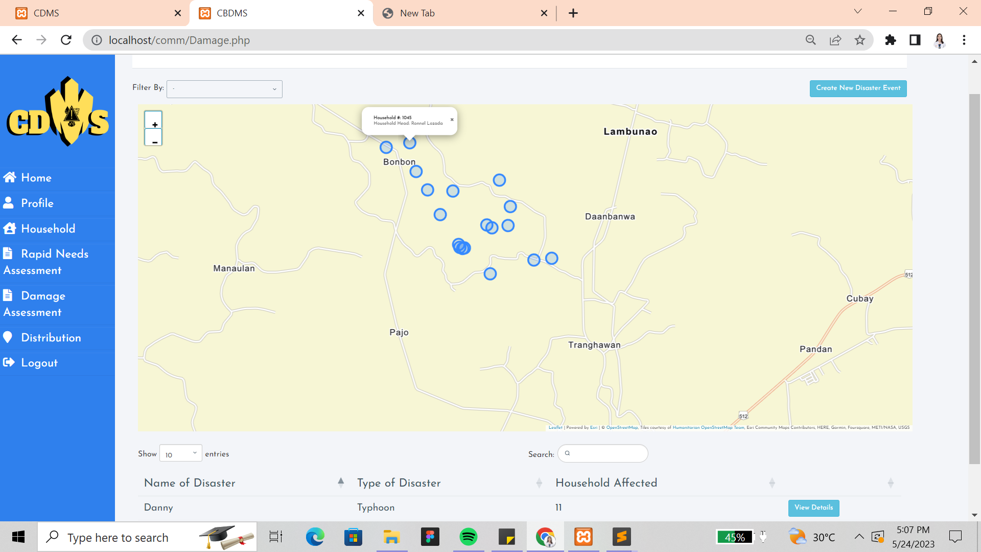

**Figure 20.** Damage Assessment

Figure 20 shows the damage assessment tab to map out those damaged infrastructures. It also shows all the information such as what kind of infrastructure there is and if it is partially or totally damaged.

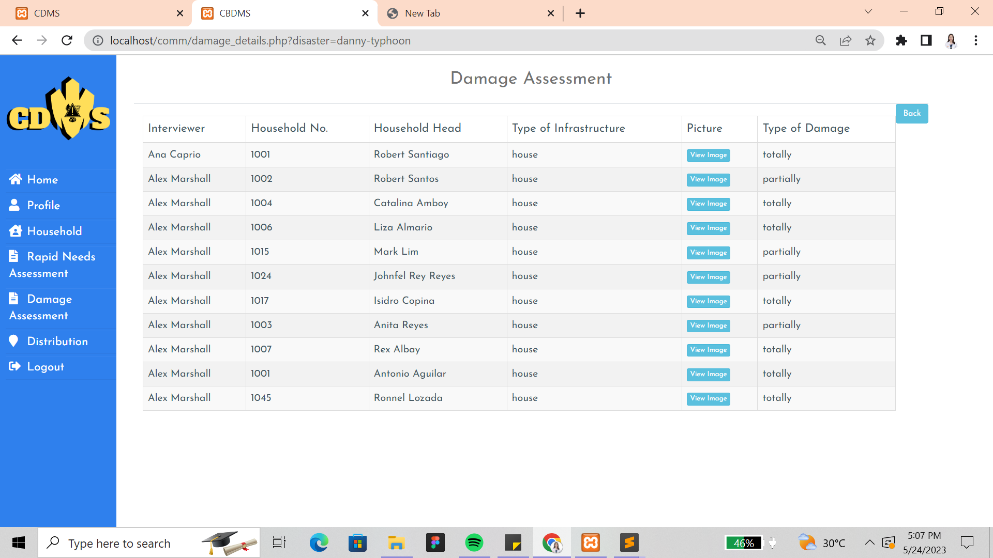

**Figure 21.** Picture of Damage Infrastructure

Figure 21 shows an option to view the image/picture of the damaged infrastructure for validation and to assess what type of damage has occurred.

**Figure 22.** Distribution Route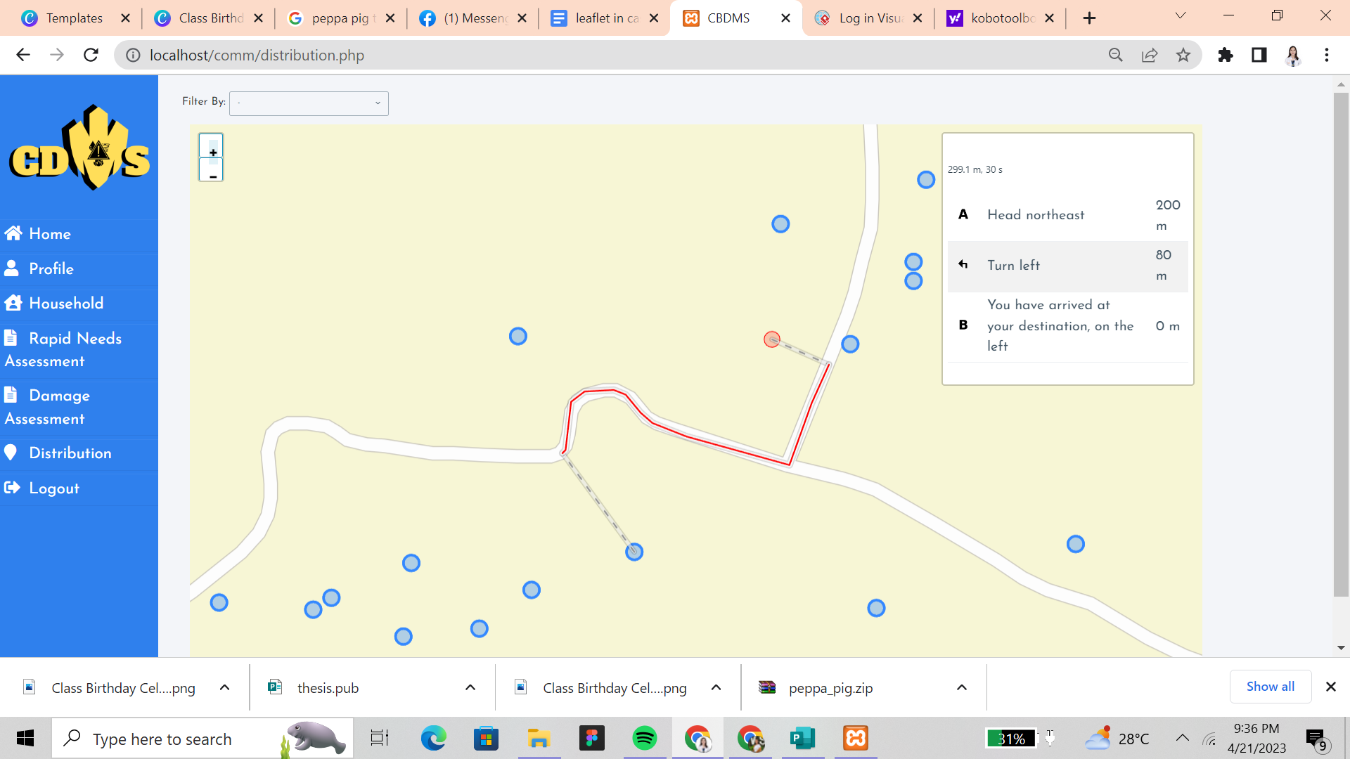

Figure 22 shows the shortest route between the 2 points for the distribution of the urgent needs of the vulnerable population.

Results Interpretation and Analysis

The researchers proposed a Community Disaster Management System with Rapid Assessment and Damage Reporting which easily monitors the affected households and family in times of disaster to provide immediate care. The system was able to get data from KoboToolbox through API. The system was able to map and calculate the shortest route of the household for monitoring and distribution of urgent needs. The admin was able to add, update, and delete data in KoboToolbox through the integration of API that was imported in the system. In Rapid Assessment, the system was able to gather the data of household information and the people who are missing, injured and dead. All the data gathered and analyzed by the system were able to generate summarized reports about a certain disaster to be submitted to the Municipal Disaster Risk Reduction Management Office for the reporting.

In order to achieve the objectives of this study, the Waterfall method includes analysis, requirement specification, design, development, testing, and implementation was utilized by the researchers to complete the requirements. Interviews were conducted to the MDRRMO representative and Barangay captain for data gathering and for the development of the system. The overall mean of the system evaluation was “Very Satisfactory” with a total mean of 4.165.

The system was beneficial most especially to the community in terms of prioritization of the vulnerable population, identifying the affected persons, damaged infrastructures and prioritizing the individual’s safety and needs in times of disaster. The system was able to generate reports and alleviate the suffering of the people in the community. With the system, it is easier to respond and monitor the household efficiently and save more lives compared to the methods they used before that caused delays in response and recovery.

System Evaluation Results

The system was presented to a panel of evaluators which are the end users of the system. The ISO/IEC 25010 was utilized to assess the degree to which the system satisfies the presented requirements of the users and provides function to the research problem.

The criteria for evaluation consist of eight sections that consist of the following: Functional Sustainability, Performance Efficiency, Compatibility, Usability, Reliability, Security, Maintainability and Portability. Using the five-point scale, the form comprises thirty-one (31) statements to measure the quality of the system. Evaluators rated each criterion accordingly and the results were compiled in mean.

|  |  |  |
| --- | --- | --- |
| Scale  5  4  3  2  1 | Range  4.21-5.00  3.41-4.20  2.61-3.40  1.81-2.60  1.00-1.81 | Interpretation  Excellent  Very Satisfactory  Satisfactory  Fair  Poor |

*Users’ Evaluation*

The evaluation showed that in the Functional Stability, the jurors rated functional completeness, functional corrections, and functional appropriateness “Very Satisfactory” with the mean of 3.70. As to Performance Efficiency, the jurors rated time behavior, resource utilization, and capacity, “Excellent” with the mean of 4.35. For Compatibility, the jurors rated co-existence, and interoperability “Very Satisfactory” with the mean of 3.67. While in Usability, the jurors rated appropriateness, recognizability, learnability, operability, user error protection, user interface aesthetics, and accessibility “Excellent” with a mean of 5.On the other hand as to Reliability, the jurors rated maturity, availability, fault tolerance, and recoverability “Excellent” with a mean of 4.30. Whereas to Security, the jurors rated confidentiality, integrity, non-repudiation, accountability, and authenticity “Very Satisfactory” with a mean of 4. In Maintainability, the jurors rated modularity, reusability, analyzability, modifiability, and testability “Very Satisfactory” with a mean of 4. Lastly, for portability, the jurors rated adaptability, instability, and replaceability “Excellent” with a mean of 4.30. The overall total of user evaluation of the system has a grand mean of 4.165 which is interpreted as “Very Satisfactory”.

**Table 2**

*Evaluation Results for the Proposed System*

**Criteria Mean Description** 

Functional Stability 3.7 Very Satisfactory

Performance Efficiency 4.35 Excellent

Compatibility 3.67 Very Satisfactory

Usability 5 Excellent

Reliability 4.3 Excellent

Security 4 Very Satisfactory

Maintainability 4 Very Satisfactory

Portability 4.3 Excellent

**Overall Evaluation 4.165 Very Satisfactory**

CHAPTER 5 SUMMARY, CONCLUSION, AND RECOMMENDATIONS

Summary of Proposed Study Design and Implementation

This study entitled “Community Disaster Management System with Rapid Assessment and Damage Reporting”, aimed to develop a system that can generate data on households, especially the vulnerable populations such as children, elders, and persons with disabilities, by integrating with offline collection tools and mapping of households using an OpenstreetMap.

Beforehand, the data of the household should be collected and imported into the system. Through that, the system was able to integrate the KoboToolbox API and import data into the system and only the admin and data collectors can edit, delete, and add data. The system was able to calculate short paths through leaflet routing machines and generate maps.

The system has integrated an instrument for conducting rapid needs assessment for prioritizing the urgent needs of vulnerable populations, identifying the missing, injured persons and the number of deaths after the disaster. Moreover, there was also a damage assessment for analysis and reporting such as the damage infrastructures and identifies the type of damage. The web-based system was developed using Sublime text as IDE, XAMPP for local hosting, PHP, HTML, CSS and Javascript.

Summary of Findings

This research aimed to develop a community disaster management system with rapid assessment and damage reporting. The researchers gathered and compiled the data from the MDRRMO and the Barangay for more background information of their process on how to conduct assessments and respond to the disaster. The data that have been gathered were the basis in development of the system. The integration of the KoboToolbox API was the primary point to develop the system since it was to gather and import the data in the system. The system was able to calculate the shortest route for the distribution of urgent needs of the vulnerable population. Also, the system was able to generate reports through importing the household, rapid, damage into the system.

In testing the system, ten (10) responses were gathered for the user evaluation that was based on the ISO/IEC 2501o Standard Software Evaluation Tool. After a thorough evaluation and demonstration of the system, the results showed a “Very Satisfactory” response from the target users of the application.

Based on the suggestions and recommendations of the users from the evaluation, the application is still subject for improvements and needs to enhance the interface and functionalities that can help them to use the system easily and conveniently.

Conclusions

The researchers were able to achieve the objectives that were implemented for the study. After a thorough evaluation, certain observations were done.

The researchers were able to develop a system that integrates an offline data collection tool called KoboToolbox that collects the data of household information, rapid needs, and damage reports of the community. The system was able to pull the data once the internet was detected and was able to map the household through its location and determine what household has a PWD, children and senior citizens. Moreover, the system was able to generate reports in rapid needs and damage assessment that was recorded by the data collector after the disaster. These reports were the basis in identifying the affected households and individuals especially the missing, injured, and dead.

At the same time, the damage tab was able to generate reports of infrastructures that were destroyed by the disaster with a photo for validation. The system was also able to calculate the shortest path using the Openstreetmap to determine the fastest route for distribution of needs of the vulnerable population.

After successfully implementing the features mentioned, the application was then evaluated by the users based on ISO 25010 Standard Software Evaluation Tool. The user evaluation results overall showed “Very Satisfactory” rating from the users. Therefore, it is concluded that the users think that the system is usable and easy to use in times of disaster.

Recommendations

Considering the results that are previously presented and the conclusion discussed, the following are the recommendations for the improvement of the system:

1. Implement hazard analysis for the review of vulnerability of life, identification of possible hazards, probability, intensity and the impact area.
2. Improve the scope of the system into multiple barangays or municipalities.
3. Improve the map in the household by putting color coding of the levels of risks in flood prone areas.
4. Implement the community-based preparedness and early warning messages that help in saving lives, protecting property, and reducing economic losses through preparing the community for the upcoming disaster.

References

Ahmed, S., Ibrahim, R. F., & Hefny, H. A. (2017, July).

GIS-based network analysis for the roads network of the Greater Cairo area. In *Proc. of 2nd International Conference on Applied Research in Computer Science and Engineering*.

ArcGis.(2019).An overview of the To Shapefile toolset.

Retrieved from

<https://desktop.arcgis.com/en/arcmap/10.6/tools/conversion-toolbox/an-overview-of-the-to-shapefile-toolset.htm#:~:text=A%20shapefile%20is%20a%20simple,%2C%20or%20polygons%20(areas).&text=Copies%20the%20features%20from%20one,to%20a%20folder%20of%20shapefiles>.

Aydin, C., Tarhan, C., Ozgur, A. S., & Tecim, V.

(2016).Improving disaster resilience using mobile based disaster management systems. Procedia Technology, 22, 382-390.

Bala, M. M., Navya, K., & Shruthilaya, P. (2017). Text

mining on real time Twitter data for disaster response. *Int. J. Civ. Eng. Technol*, *8*(8), 20-29.

Clermont County Ohio Emergency Management

Agency.(2023).Damage Assessment. Retrieved from

<https://ema.clermontcountyohio.gov/damage-assessment/>

Fajardo, J. T. B., & Oppus, C. M. (2010). A mobile disaster

management system using the android technology. WSEAS Transactions on Communications, 9(6), 343-353.

Flax, L. K., Jackson, R. W., & Stein, D. N. (2002).

Community vulnerability assessment tool methodology.

*Natural Hazards Review*, *3*(4), 163-176.

Habiba, M., & Akhter, S. (2013). A cloud based natural

disaster management system. In Grid and Pervasive

Computing: 8th International Conference, GPC 2013 and Colocated Workshops, Seoul, Korea, May 9-11, 2013. Proceedings 8 (pp. 152-161). Springer Berlin Heidelberg.

He, Y., Zhang, D., & Fang, Y. (2017). Development of a

mobile post-disaster management system using free and open source technologies. International journal of disaster risk reduction, 25, 101-110.

Kryvasheyeu, Y., Chen, H., Obradovich, N., Moro, E., Van

Hentenryck, P., Fowler, J., & Cebrian, M. (2016).

Rapid assessment of disaster damage using social media

activity. *Science advances*, *2*(3), e1500779.

Mali, V., Rao, M., & Mantha, S. S. (2013,January). AHP

driven GIS based emergency routing in disaster

management. In the International *Conference on Advances in Computing, Communication and Control* (pp. 237-248).

Springer, Berlin, Heidelberg.

Matveev, A., Maximov, A., & Bogdanova, E. (2020). Intelligent decision support system for transportation emergency response. *Transportation Research Procedia*, *50*, 444-450.

Meilani, D., Hadiguna, R. A., & Pradipta, C. A. (2021,

April). Geographical information system for disaster

relief distribution on natural disaster response. In *IOP Conference Series: Earth and Environmental Science* (Vol. 708, No. 1, p. 012089). IOP Publishing.

Natividad, J. G., & Mendez, J. M. (2018, March). Flood

monitoring and early warning system using ultrasonic

sensor. In *IOP conference series: materials science and engineering* (Vol. 325, No. 1, p. 012020). IOP Publishing.

Sangwan, S. (2018).Literature Review on Travelling Salesman

Problem. *International Journal of Research*, 5(16).

Satria, D., Yana, S., Hidayat, T., Syahreza, S., Yusibani,

E., & Munadi, R. (2019, September). Application of GSM communication system on flood alarm systems. In *Journal of Physics: Conference Series* (Vol. 1232, No. 1, p. 012023). IOP Publishing.

Satria, D., Yana, S., Munadi, R., & Syahreza, S. (2017).

Prototype of Google maps-based flood monitoring system

using Arduino and GSM module. Int. Res. J. Eng.

Technol, 4(10), 1044-1047.

Sejera, M. M., Ballado, A. H., Fernando, B. N. H.,

Montemayor, M. F. I. A., & Niebres, A. V. D. (2020,

June). Mobile App-Based Early Warning System for

Landslides Using Land Monitoring Through GSM. In *2020*

*IEEE Region 10 Symposium (TENSYMP)* (pp. 90-93). IEEE.

Srivastava K. (2010). Disaster: Challenges and

perspectives. *Industrial psychiatry journal*, *19*(1), 1–4. <https://doi.org/10.4103/0972-6748.77623>.

Tuna, G., Gungor, V. C., & Gulez, K. (2014). An autonomous wireless sensor network deployment system using mobile robots for human existence detection in case of disasters. *Ad Hoc Networks*, *13*, 54-68.

UNHCR.(2016).Kobo Guidelines. Retrieved from

[https://www.humanitarianresponse.info/sites/www.humani tarianresponse.info/files/documents/files/unhcr_kobo_guidelines_may2016.pdf](https://www.humanitarianresponse.info/sites/www.humani%20tarianresponse.info/files/documents/files/unhcr_kobo_guidelines_may2016.pdf)

UNISDR.(2015).Sendai Framework for Disaster Risk Reduction

2015 - 2030. Retrieved from [https://www.preventionweb.net/files/43291_sendaiframeworkfrdrren.pdf](https://www.preventionweb.net/files/43291_sendaiframeworkfordrren.pdf)

USAID.(2016).SBCC For Emergency Preperenes I-KIT.

Retrieved from

<https://sbccimplementationkits.org/sbcc-in-emergencies/lessons/unit-2-rapid-needs-assessment/>

Appendices

Appendix A

Letter to the Adviser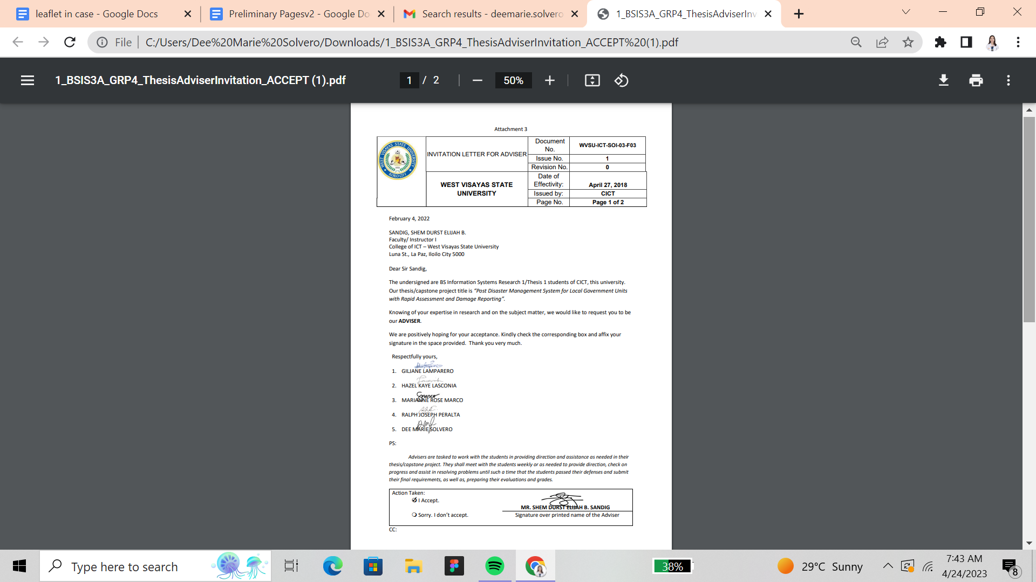

Appendix B

Letter to the Editor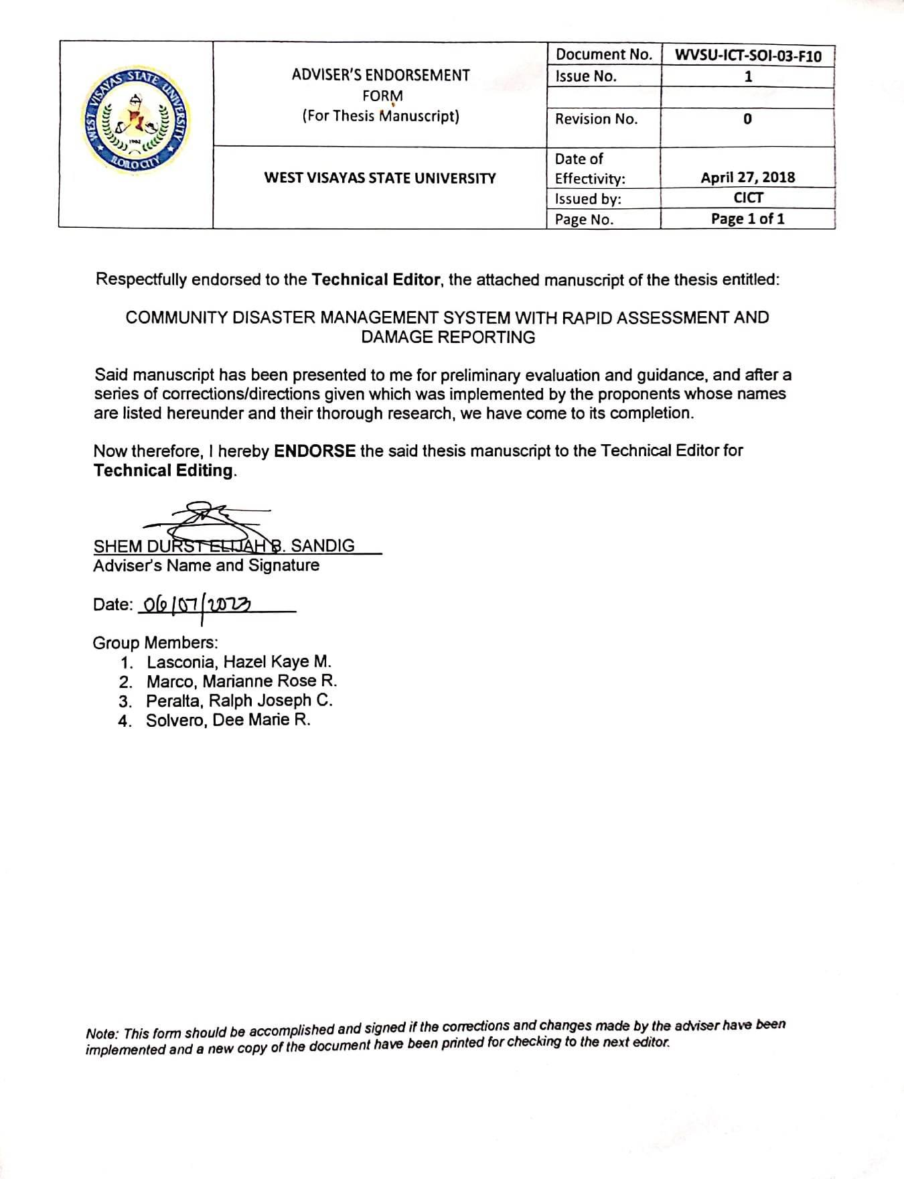

Appendix B

Letter to the Editor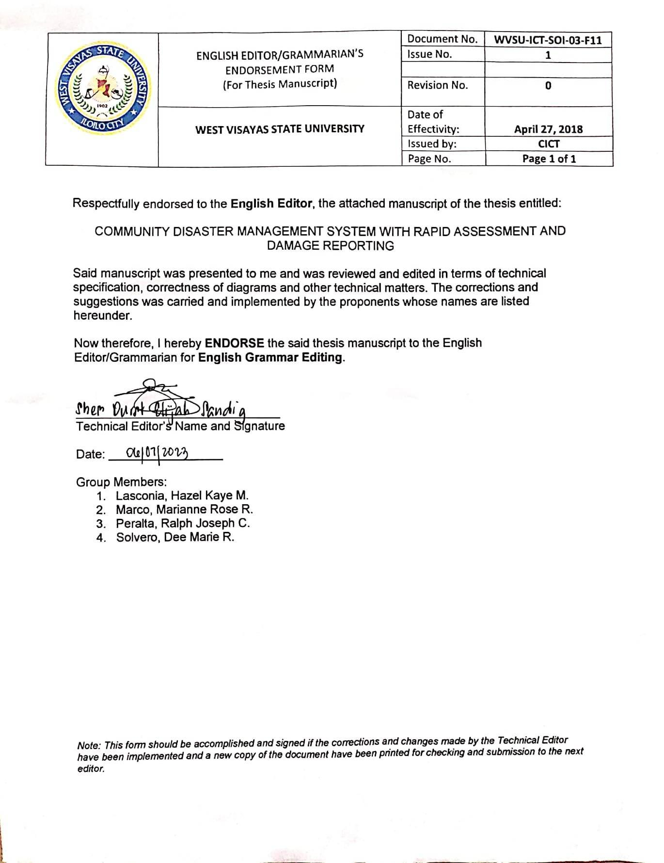

Appendix B

Letter to the Editor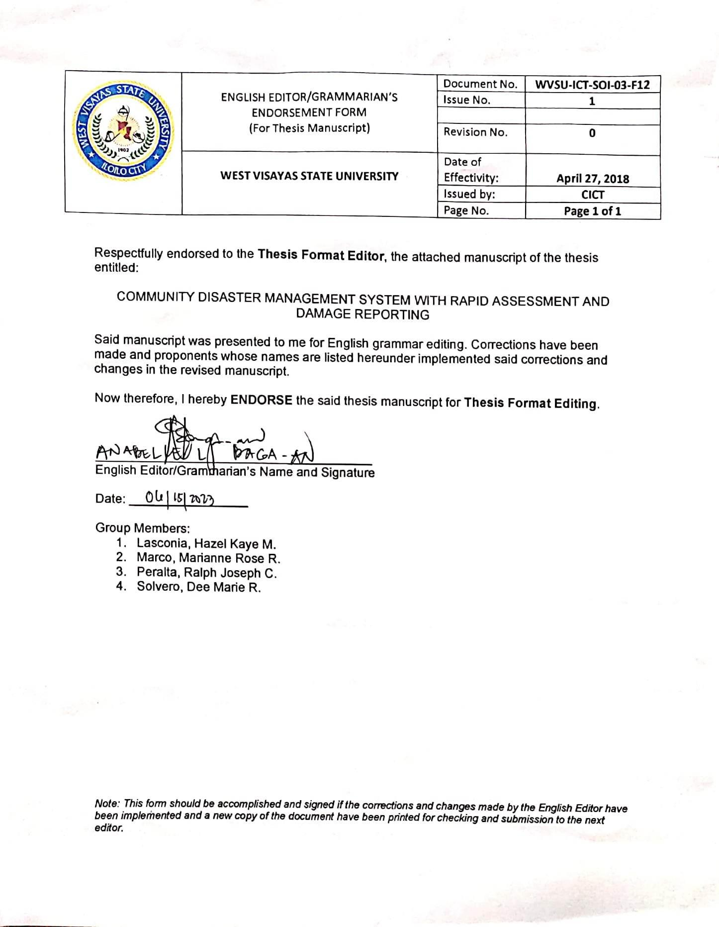

Appendix B

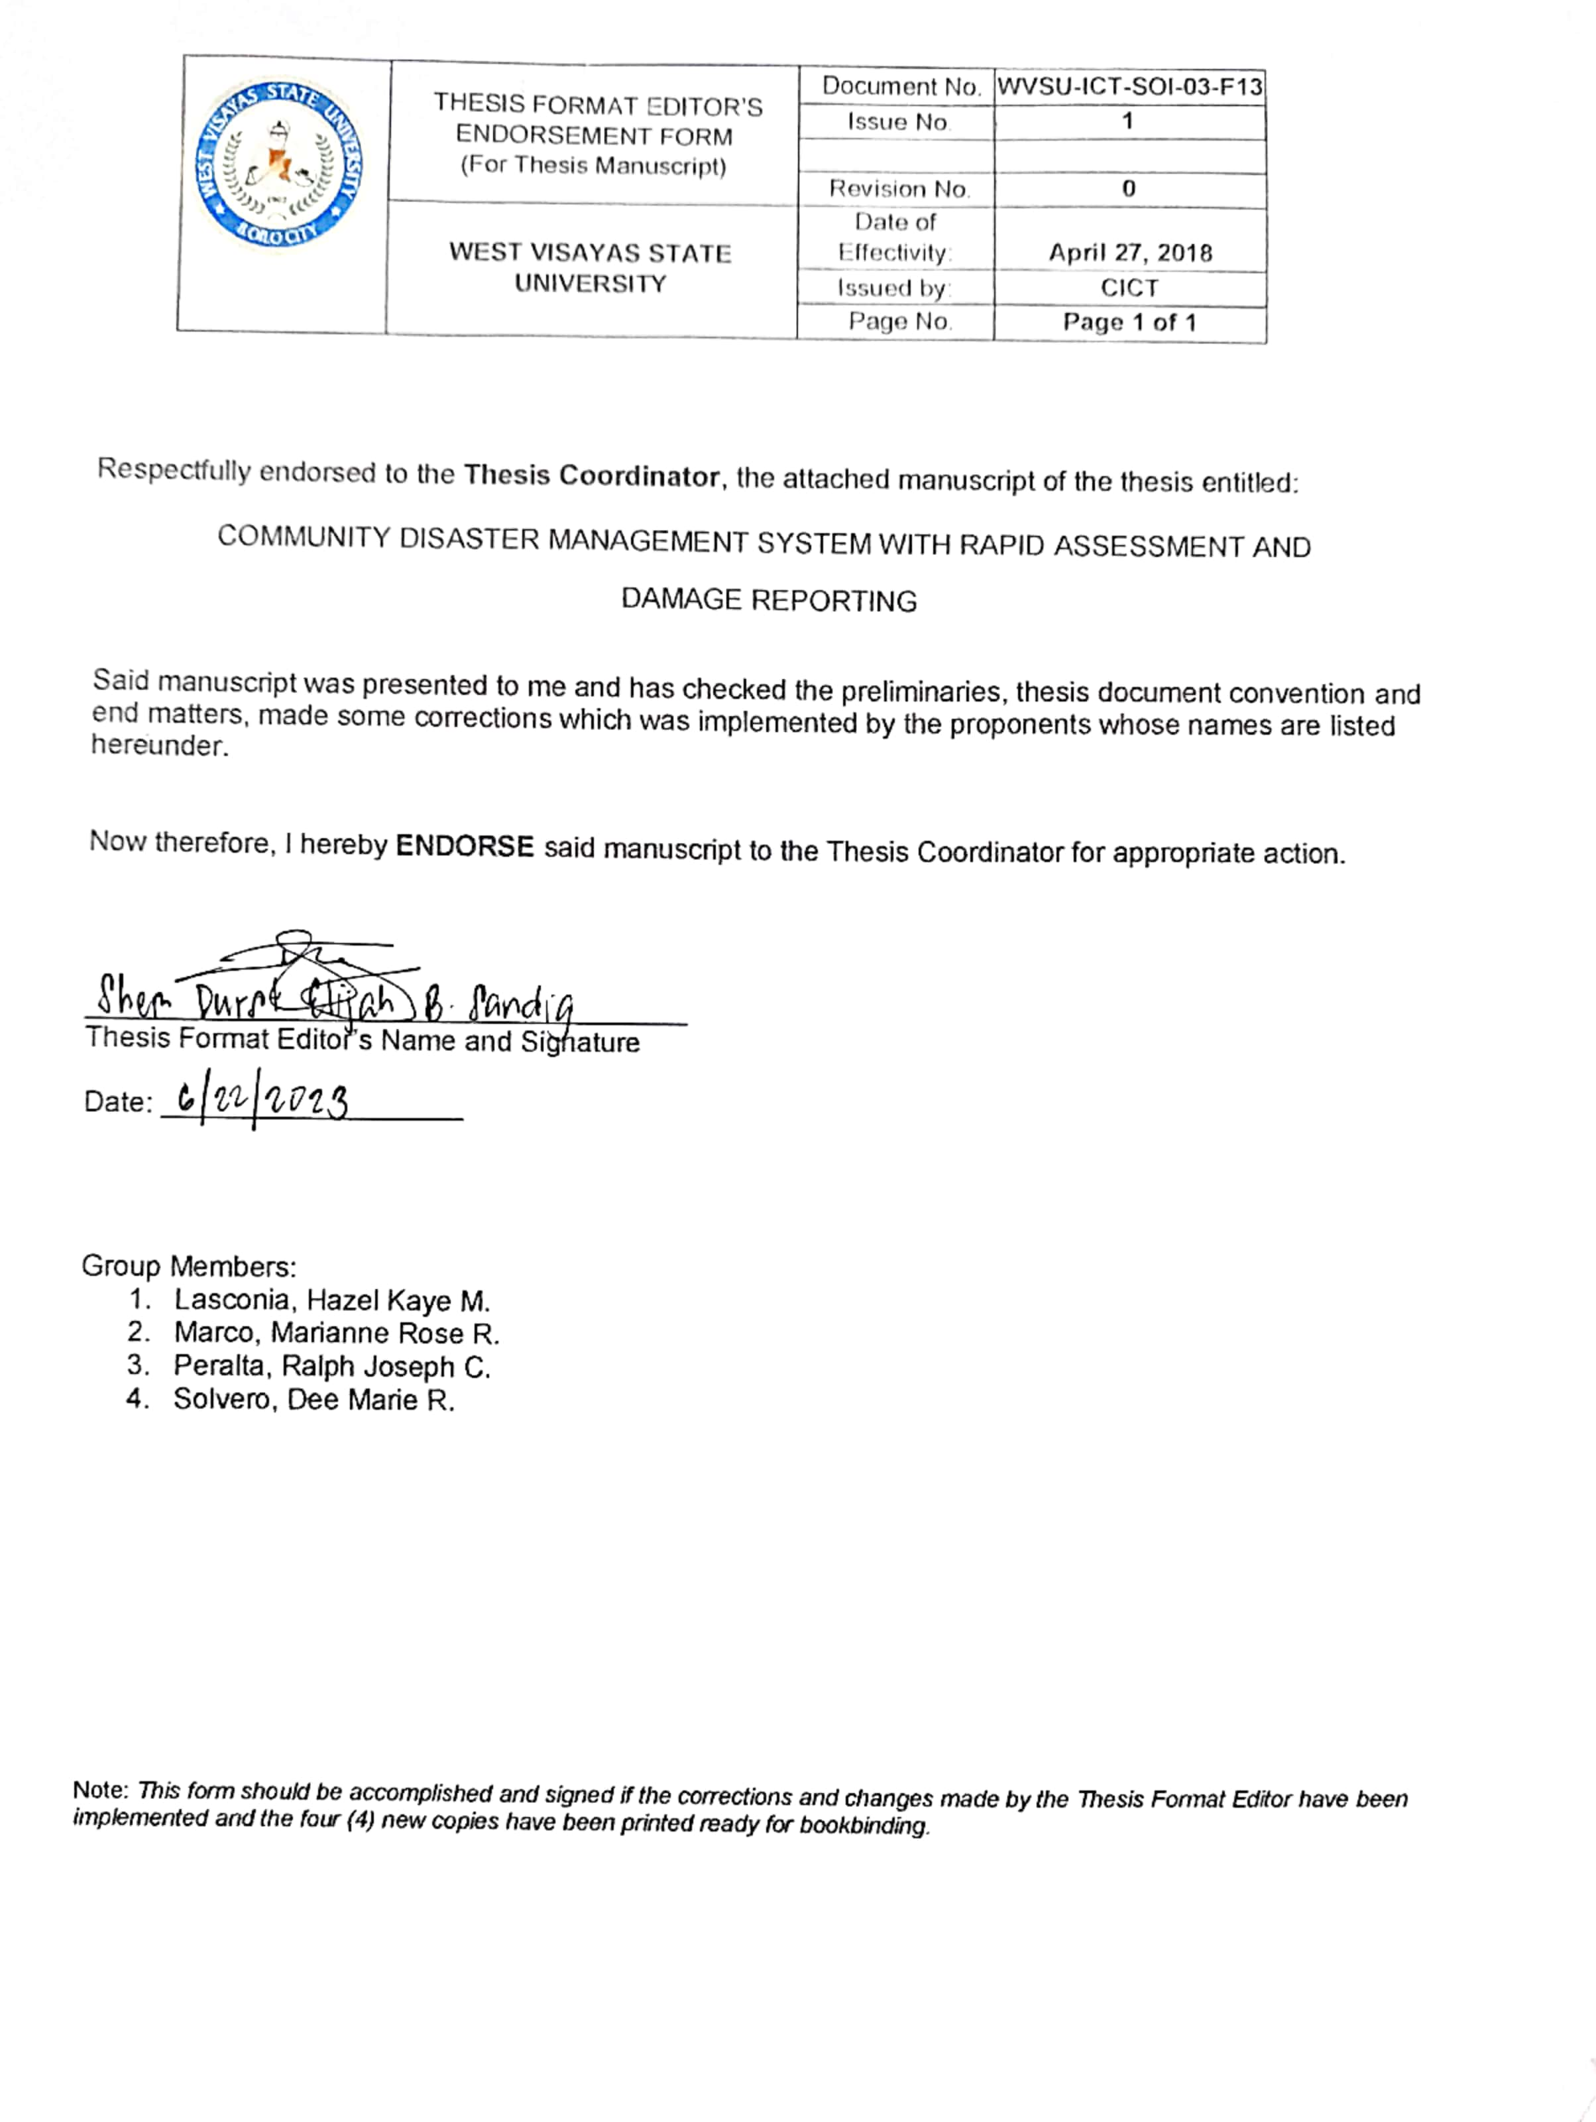Letter to the Editor

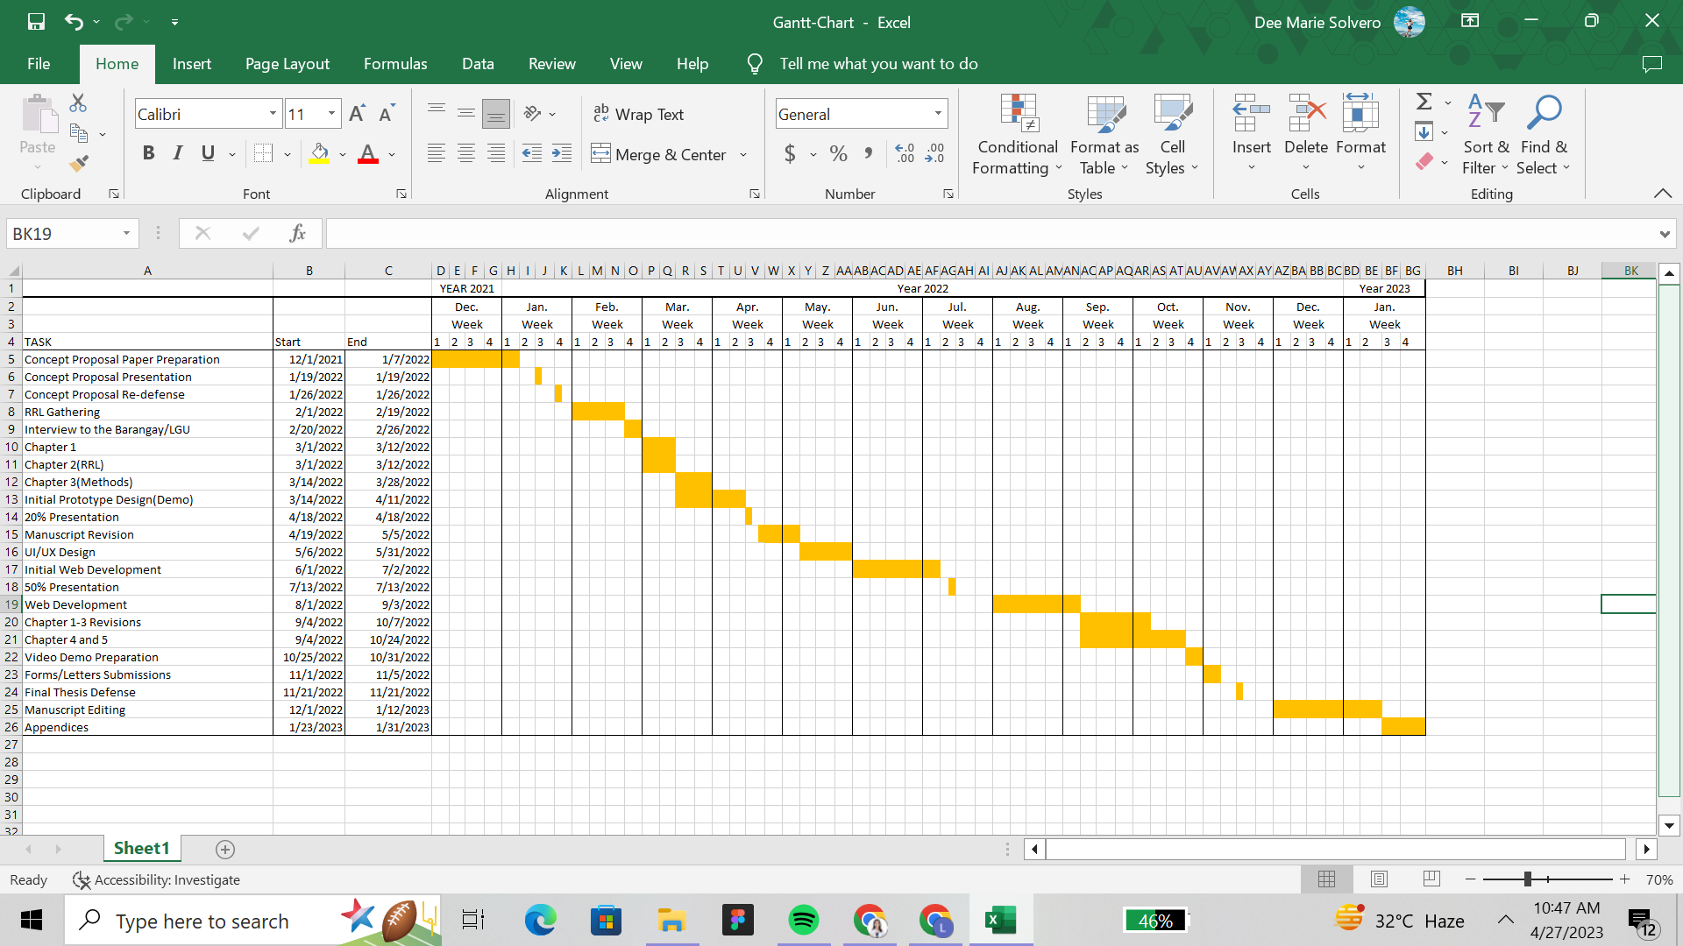Appendix C

Gantt Chart

Appendix D

Data Dictionary

User Login

|  |  |  |  |
| --- | --- | --- | --- |
| Field Name | Data Type | Description | Required? |
| id (Primary) | int(100) | Unique user id | Y |
| name | varchar(100) | name of the user | Y |
| email | varchar(100) | Username of the user | Y |
| password | varchar(100) | login password of the users | Y |
| image | varchar(100) | filename of an image | N |

Disaster Event

|  |  |  |  |
| --- | --- | --- | --- |
| Field Name | Data Type | Description | Required? |
| Disaster_Event | varchar(255) | Name of Disaster | Y |
| Type_of_Disaster | varchar(255) | Type of Disaster | Y |
| Date_and_Time_of_Occurrence | datetime | date and time of occurrence of disaster | Y |

Damage Assessment

|  |  |  |  |
| --- | --- | --- | --- |
| Field Name | Data Type | Description | Required? |
| Interviewer | varchar(255) | Person who conduct the assessment | y |
| Household_Number | int | household number | Y |
| Household_Head | varchar(255) | name of household head | Y |
| did_the_household_evacuate | varchar(255) | if they evacuated or not | Y |
| Type_of_infrastructure | varchar(255) | type of infrastructure | Y |
| Picture | varchar(255) | filename of an image | Y |
| Type_of_Damage | varchar(255) | type of damage in infrastructure | Y |
| location | varchar(255) | Location of house | Y |

Rapid Assessment Form

|  |  |  |  |
| --- | --- | --- | --- |
| Field Name | Data Type | Description | Required? |
| interviewer | varchar(255) | name of interviewer | Y |
| household_number | varchar(255) | household number | Y |
| household_head | varchar(255) | name of household head | Y |
| did_the_household_evacuate | varchar(255) | if they evacuated or not | Y |

Injured

|  |  |  |  |
| --- | --- | --- | --- |
| Field Name | Data Type | Description | Required? |
| Last_Name_001 | varchar(255) | last name of affected person | Y |
| First_Name_001 | varchar(255) | first name of affected person | Y |
| Gender_001 | varchar(255) | age of affected person | Y |
| Age_001 | varchar(255) | gender of affected person | Y |
| PWD_001 | varchar(255) | if they are PWD | Y |
| Type of Injury | varchar(255) | type of their injury | Y |
| Picture_001 | varchar(255) | filename of an image | N |

Dead

|  |  |  |  |
| --- | --- | --- | --- |
| Field Name | Data Type | Description | Required? |
| Last_Name_002 | varchar(255) | last name of affected person | Y |
| First_Name_002 | varchar(255) | first name of affected person | Y |
| Gender_002 | varchar(255) | age of affected person | Y |
| Age_002 | varchar(255) | gender of affected person | Y |
| Part_of_DAP_s_002 | varchar(255) | if they are PWD | Y |
| Cause_of_Death | varchar(255) | cause of death | Y |
| Picture_002 | varchar(255) | filename of an image | N |

Missing

|  |  |  |  |
| --- | --- | --- | --- |
| Field Name | Data Type | Description | Required? |
| Last_Name | varchar(255) | last name of affected person | Y |
| First _Name | varchar(255) | first name of affected person | Y |
| Gender | varchar(255) | age of affected person | Y |
| Age | varchar(255) | gender of affected person | Y |
| Part_of_DAP_s | varchar(255) | if they are PWD | Y |
| Picture | varchar(255) | filename of an image | N |

Barangay

|  |  |  |  |
| --- | --- | --- | --- |
| Field Name | Data Type | Description | Required? |
| interviewer | String | name of interviewer | Y |
| barangay | String | barangay name | Y |
| purok_sitio | int | sitio number in barangay | Y |
| barangay_psgc | varchar | barangay psgc ID | Y |

Head of Household Information

|  |  |  |  |
| --- | --- | --- | --- |
| Field Name | Data Type | Description | Required? |
| respondent_name | String | name of respondent | Y |
| respondent_dob | date | date of birth of respondent | Y |
| respondent_age | int | age of respondent | Y |
| respondent_gender | String | gender of responded | Y |
| hh_head_name | String | name of household head | Y |
| hh_head_age | int | age of household head | Y |
| hh_head_sex | String | sex of household head | Y |
| primary_contact_number | int | number of household head | Y |

Household Information

|  |  |  |  |
| --- | --- | --- | --- |
| Field Name | Data Type | Description | Required? |
| hh_household_unq_id | varchar | auto generated | Y |
| hh_address | varchar | address of household head | Y |
| hh_ownership | String | ownership of household head | Y |
| hh_construction_materials | String | materials of household head | Y |
| toilet_used | String | toiled used of household | Y |
| with_concrete_septic_tank | String | septic tank of household | Y |
| source_of_water | String | source of water of household | Y |
| source_of_light | String | source of light of household | Y |
| hh_geo_hazard | String | if the household is located in the hazard area | N |
| hh_geo_hazard_type | String | type of hazard | N |
| hh_location | varchar | location of house | N |
| hh_photo | varchar | filename of an image | Y |

Household Member Information

|  |  |  |  |
| --- | --- | --- | --- |
| Field Name | Data Type | Description | Required? |
| name_number | int | auto generated | Y |
| hh_individual_unq_id | varchar | auto generated | Y |
| hh_member_last_name | String | hh member last name | Y |
| hh_member_first_name | String | hh member first name | Y |
| hh_member_middle_name | String | hh member middle name | Y |
| hh_member_complete_name | String | hh member complete name | Y |
| hh_relationship_to_head | String | hh member relationship to household head | Y |
| hh_member_dob | date | dob of hh member | Y |
| hh_member-age | int | age of hh member | Y |
| hh_member_sex | String | sex of hh member | Y |
| hh_member_marital_statud | String | marital status of hh member | N |
| hh_member_disability_type | String | type of disability | N |
| hh_member_occupation | String | hh member occupation | N |
| hh_member_monthly_income | int | monthly income of hh member | Y |
| Is_hh_member_first_primary_income_earner | String | if the hh member is the primary earner | Y |
| hh_member_religion | String | religion of hh member | Y |
| hh_member_ip | String | if household is part of IP | N |
| hh_member_ip_tribe_group | String | name of IP group | N |
| hh_birth_order | int | order in the family of household head | Y |
| hh_birthplace | varchar | birthplace of household head | Y |
| name_of_mother | String | mother of household head | Y |
| dob_of_mother | date | hh head mother birthdate | Y |
| marital_status_of_mother | String | marital status of hh head mother | N |
| occupation_of_mother | String | mother of household head | N |
| religion_of_mother | String | household head mother religion | N |
| hh_num_of_families | int | number of families of household head | Y |
| family_number | int | number of families in household | Y |
| family_unq_id | varchar | family unique id, auto generated | Y |
| num_hh_members | int | number of members in the household | Y |
| num_hh_adults | int | number of adults in the household | Y |
| num_hh_children | int | number of children in the household | Y |
| hh_language | String | language used in household | N |
| record_status | String | status of household | Y |

Appendix E

Entity-Relationship Diagram



Appendix F

Sample Program Codes

**Dashboard.php**

$kobo_api = new KOBO_API();

$data_damage = $kobo_api->getDataByAPI(DAMAGE_ASSESSMENT_API);

$data_master = $kobo_api->getDataByAPI(MASTER_LIST_API);

$data_rapid = $kobo_api->getDataByAPI(RAPID_NEEDS_ASSESSMENT_API);

#$sortedArray = $kobo_api->sortRawData($data);

$new_data_rapid = $kobo_api->recursive_change_key($data_rapid, array(

'Household_Information/Household_Number' => 'Household_Number',

'Household_Information/Household_Head' => 'Household_Head',

'Date_and_Time_of_Occurrence' => 'Date_and_Time_of_Disaster_Occurrence',

'Household_Information/Does_the_household_have_evacuated' => 'Does_the_household_have_evacuated',

'Missing_Person/Gender' => 'Missing_Gender',

'Injured_Person/Injured_Gender' => 'Injured_Gender',

'Dead_Person/Dead_Gender' => 'Dead_Gender',

));

$arr = array_merge($data_damage, $new_data_rapid);

$sortedArray = $kobo_api->sortRawData($arr);

$persons_affected = 0;

$male_affected = 0;

$female_affected = 0;

**Distribution.php**

$kobo_api = new KOBO_API();

$data = $kobo_api->getDataByAPI(DAMAGE_ASSESSMENT_API);

#$sortedArray = $kobo_api->sortRawData($data);

// echo "<pre>";

// print_r($data);

if (isset($_GET['filter_by'])):

$filter_by = $_GET['filter_by'];

else:

$filter_by = "-";

endif;

?>

**Household.php**

foreach ($data as $repository) : ?>

<tr>

<td> <?= $repository["purok_sitio"] ?></td>

<td> <?= $repository["hh_info/hh_household_number"] ?></td>

<td> <?= $repository["respondent_info/respondent_name"] ?></td>

<td> <?= $repository["respondent_info/respondent_gender"] ?></td>

<td> <?= $repository["respondent_info/primary_contact_number"] ?></td>

<td> <?= $repository["hh_info/hh_ownership"] ?></td>

<td>

<?php

if (!empty($repository["hh_info/hh_geo_hazard_type"])) :

$geo_hazard = str_replace("_"," ", $repository["hh_info/hh_geo_hazard_type"]);

echo ucwords($geo_hazard);

else:

echo "";

endif;

?>

</td>

<td> <?= $repository["hh_family_info/hh_num_of_families"] ?></td>

<td> <?= $repository["hh_family_info/num_hh_members"] ?></td>

<td> <?= $repository["hh_family_info/num_hh_adults"] ?></td>

<td> <?= $repository["hh_family_info/num_hh_children"] ?></td>

</tr>

<?php endforeach; ?>

**rapid.php**

if (!is_connected()) :

$kobo_api = new KOBO_API();

$data = $kobo_api->getDataByAPI(RAPID_NEEDS_ASSESSMENT_API);

$sortedArray = $kobo_api->sortRawData($data);

else:

$kobo_api = new KOBO_API();

$rapid_data = "SELECT *, GROUP_CONCAT(' ', id) AS ids FROM `rapid_needs` GROUP BY `Disaster_Event`";

$rapid_data_sql = mysqli_query($conn, $rapid_data);

//$sortedArray = mysqli_fetch_array($rapid_data_sql);

//$sortedArray = $kobo_api->sortRawData($result);

// echo "<pre>";

// print_r($result);

endif;

if (isset($_GET['filter_by'])):

$filter_by = $_GET['filter_by'];

else:

$filter_by = "-";

endif;

**Rapid_details.php**

$kobo_api = new KOBO_API();

$data = $kobo_api->getDataByAPI(RAPID_NEEDS_ASSESSMENT_API);

$sortedArray = $kobo_api->sortRawData($data);

// echo "<pre>";

// print_r($sortedArray[$_GET['disaster']][0]['Missing_Person']);

$data_array = $sortedArray[$_GET['disaster']];

**Rapid_information.php**

<?php foreach ($sortedArray[$_GET['disaster']][$_GET['key']]['Missing_Person'] as $key => $result): ?>

<tr>

<td>

<?php

$kobo_img_url = "https://kc.kobotoolbox.org/media/original?media_file=deemarie_solvero09/attachments/";

$form_uuid = $sortedArray[$_GET['disaster']][$_GET['key']]['formhub/uuid'];

$data_uuid = $sortedArray[$_GET['disaster']][$_GET['key']]['_uuid'];

$img_url = $sortedArray[$_GET['disaster']][$_GET['key']]['Missing_Person'][$i]['Missing_Person/Picture'];

$img_url = str_replace(array("(",")"), "", $img_url);

$img_url = str_replace(" ", "_", $img_url);

$final_img_url = $kobo_img_url.$form_uuid."/".$data_uuid."/".$img_url;

?>

<img src="<?=$final_img_url?>" alt="" width="150" loading="lazy">

</td>

<td><?=ucwords($result['Missing_Person/Last_Name'])?>, <?=ucwords($result['Missing_Person/First_Name'])?></td>

<td><?=ucwords($result['Missing_Person/Age'])?></td>

<td><?=ucwords($result['Missing_Person/Gender'])?></td>

<td><?=ucwords($result['Missing_Person/Missing_Part_of_DAP_S'])?></td>

</tr>

<?php ++$i; ?>

<?php endforeach; ?>

**Reports.php**

$kobo_api = new KOBO_API();

$data_damage = $kobo_api->getDataByAPI(DAMAGE_ASSESSMENT_API);

$data_master = $kobo_api->getDataByAPI(MASTER_LIST_API);

$data_rapid = $kobo_api->getDataByAPI(RAPID_NEEDS_ASSESSMENT_API);

#$sortedArray = $kobo_api->sortRawData($data);

$new_data_rapid = $kobo_api->recursive_change_key($data_rapid, array('Household_Information/Household_Number' => 'Household_Number', 'Household_Information/Household_Head' => 'Household_Head'));

$arr = array_merge($data_damage, $new_data_rapid);

$sortedArray = $kobo_api->sortRawData($arr);

**Damage.php**

<?php

foreach ($data as $repository) : ?>

<tr>

<td> <?= $repository["Interviewer"] ?></td>

<td> <?= $repository["Date_and_Time_of_Disaster_Occurrence"] ?></td>

<td> <?= $repository["Type_of_Disaster"] ?></td>

<td>

<?php

if (!empty($repository["Name_of_the_Type_of_Disaster"])) :

$disaster = str_replace("_"," ", $repository["Name_of_the_Type_of_Disaster"]);

echo ucwords($disaster);

else:

echo "";

endif;

?>

</td>

<td> <?= $repository["Household_Number"] ?></td>

<td> <?= $repository["Name_of_Household_Head"] ?></td>

<td><?= $repository["Type_of_Infrastructure"] ?></td>

<td>

<!-- <?= $repository["Take_a_picture_of_th_amage_infrastructure"] ?> <i class="fas fa-image"> -->

<?php

if (is_array($repository["_attachments"])):

//echo 1;

foreach ($repository["_attachments"] as $attachment):

echo "<a class='btn btn-info btn-xs' target='_blank' href='".$attachment['download_url']."' >View Image</a>";

endforeach;

else:

echo 0;

endif;

?>

</td>

<td> <?= htmlspecialchars($repository["Type_of_Damage"]) ?></td>

</tr>

<?php endforeach; ?>

Appendix G

Pert-CPM

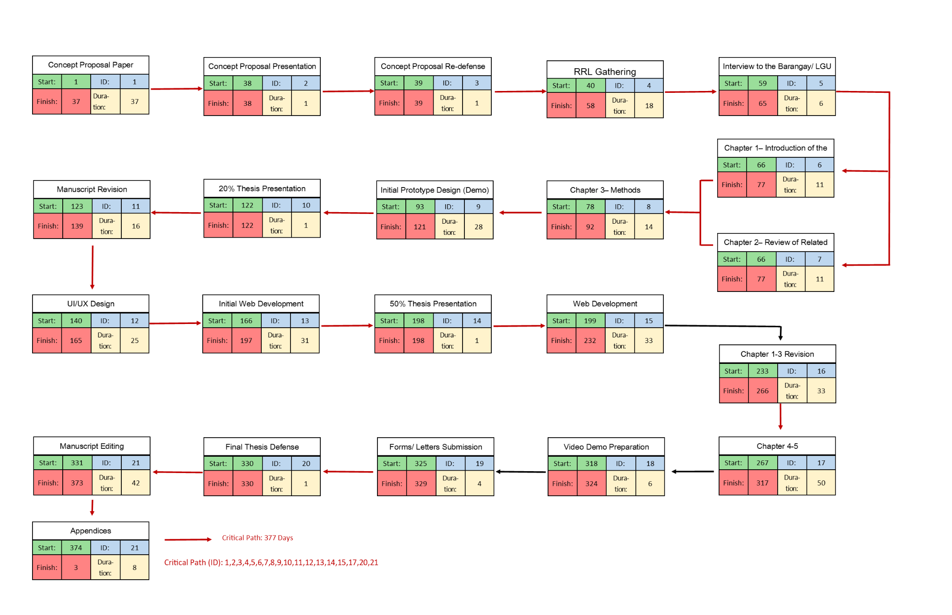

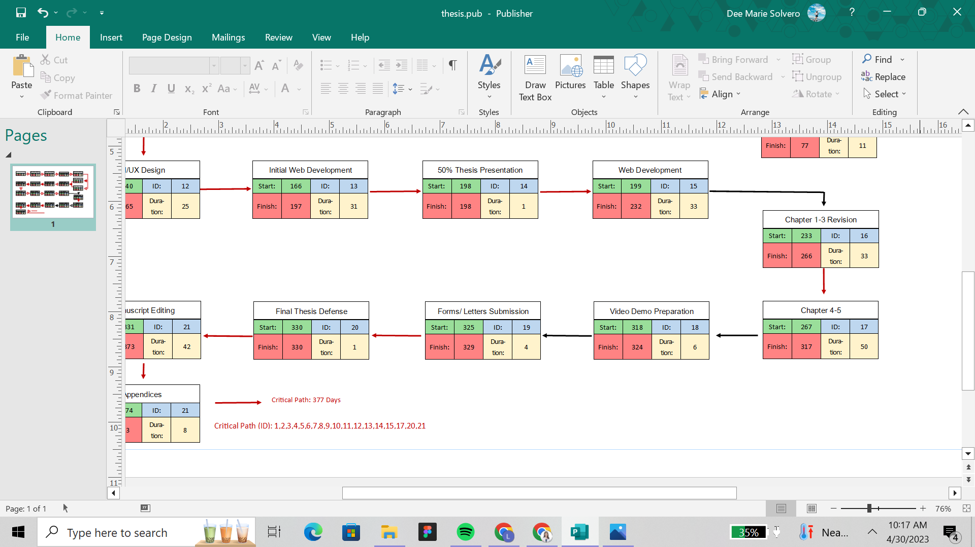

Appendix H

ISO 25010 Software Evaluation Form

1. Software: Community Disaster Management System with Rapid Assessment and Damage Reporting

Name of Juror:

Position/ Designation:

1. Instructions. Please rate by putting a checkmark on how you agree or disagree with the following statements.

1 - Poor

2 - Fair

3 - Satisfactory

4 - Very Satisfactory

5 - Excellent

|  |  |  |  |  |  |
| --- | --- | --- | --- | --- | --- |
|  | 1 | 2 | 3 | 4 | 5 |
| A. Functional Suitability |  |  |  |  |  |
| 1. Functional completeness. The system covers all the specified tasks and  user objectives |  |  |  |  |  |
| 2. Functional correctness. The system provides the correct results with the needed degree of precision. |  |  |  |  |  |
| 3. Functional appropriateness. The system facilitates the accomplishment of specified tasks  and objectives. |  |  |  |  |  |
| B. Performance Efficiency |  |  |  |  |  |
| 1. Time behavior. The system response  and processing times perform its functions and meet requirements. |  |  |  |  |  |
| 2. Resource utilization. The system amounts and types of resources perform its functions and meet  requirements. |  |  |  |  |  |
| 3. Capacity. The system has the  maximum limits/capacity that meet requirements. |  |  |  |  |  |
| C. Compatibility |  |  |  |  |  |
| 1. Co-existence. The system can  perform its required functions efficiently while sharing a common environment and resources with other products, without detrimental impact on any other product. |  |  |  |  |  |
| 2. Interoperability. Two or more system components can exchange information that has been  exchanged. |  |  |  |  |  |
| D. Usability |  |  |  |  |  |
| 1. Appropriateness recognizability.  The users can recognize whether the  system is appropriate to their needs. |  |  |  |  |  |
| 2. Learnability. The system can be used by specified goals of learning with effectiveness, efficiency, freedom from risk and satisfaction in a specified context of use. |  |  |  |  |  |
| 3. Operability. The system has  attributes that makes it easy to operate and to control. |  |  |  |  |  |
| 4. User error protection. The system protects users against making  errors. |  |  |  |  |  |
| 5. User interface aesthetics. The system has a user interface that enables pleasing and satisfying  interaction for the user. |  |  |  |  |  |
| 6. Accessibility. The system can be used by people with widest range of characteristics and capabilities to achieve a specified goal in a  specified context of use. |  |  |  |  |  |
| E. Reliability |  |  |  |  |  |
| 1. Maturity. The system meets needs for reliability under normal operation. |  |  |  |  |  |
| 1. Availability. The system is operational and accessible when required for use. |  |  |  |  |  |
| 1. Fault tolerance. The system operates as intended despite the presence of hardware and software faults. |  |  |  |  |  |
| 1. Recoverability. The system can recover the data directly affected and re- establish the desired state of the system in the event of an interruption or a failure. |  |  |  |  |  |
| F. Security |  |  |  |  |  |
| 1. Confidentiality. The system ensures that data are accessible only to those authorized to have access. |  |  |  |  |  |
| 1. Integrity. The system prevents unauthorized access to, or modification of computer programs or data. |  |  |  |  |  |
| 1. Non-repudiation. Actions or events can be proven to have taken place so that the events or actions cannot be repudiated later in the system. |  |  |  |  |  |
| 1. Accountability. The actions of an entity can be traced uniquely to the entity in the system. |  |  |  |  |  |
| 1. Authenticity. The identity of a subject or resource can be proved to be the one claimed in the system. |  |  |  |  |  |
| G. Maintainability |  |  |  |  |  |
| 1. Modularity. The system is composed of discrete components such that a change to the component has minimal impact on other components. |  |  |  |  |  |
| 1. Reusability. A system asset can be used in more than one system, or in building other assets. |  |  |  |  |  |
| 1. Analyzability. The system is effective and efficient with which it is possible to assess the impact on a product or system of an intended change to one or more of its parts, or to diagnose a product for deficiencies or causes of failures, or to identify parts to be modified. |  |  |  |  |  |
| 1. Modifiability. The system can be effectively and efficiently modified without introducing defects or degrading existing product quality. |  |  |  |  |  |
| 1. Testability. The system is effective and efficient with which test criteria can be established for a system, product or component and tests can be performed to determine whether those criteria have been met. |  |  |  |  |  |
| H. Portability |  |  |  |  |  |
| 1. Adaptability. The system can effectively and efficiently be adapted for different or evolving hardware, software or other  operational or usage environments. |  |  |  |  |  |
| 2. Installability. The system is effective and efficient with which a system can be successfully installed and/or uninstalled in a  specified environment. |  |  |  |  |  |
| 3. Replaceability. The system can  replace another specified software for the purpose in the same  environment. |  |  |  |  |  |

Appendix I

Disclaimer

This software project and its corresponding documentation entitled “Community Disaster Management System with Rapid Assessment and Damage Reporting” is submitted to the College of Information and Communications Technology, West Visayas State University, in partial fulfillment of the requirements for the degree, Bachelor of Science in Information Systems. It is the product of our own work, except were indicated text.

We hereby grant the College of Information and Communications Technology permission to freely use, publish in local or international journal/conferences, reproduce, or distribute publicly the paper and electronic copies of this software project and its corresponding documentation in whole or in part, provided that we are acknowledged.

Hazel Kaye M. Lasconia Ralph Joseph C. Peralta

Marianne Rose R. Marco Dee Marie R. Solvero

June 2023